

Corporate Social Responsibility and its Effect on Employee Retention Intention
A QUANTITATIVE STUDY OF EMPLOYEE NEEDS, MOTIVATION FACTORS AND HYGIENE FACTORS

KADDOURA, MOHAMAD HASAN
PERERA, BULATHSINGHALAGE ERANDIKA
PAULSEN, PIA SOPHIE

School of Business, Society & Engineering
Course: Bachelor Thesis in Business Administration Supervisor: Edward Gillmore
Course code: FOA 230 Date: 06.06.20
15 cr
ABSTRACT

Date: 06.06.20
Level: Bachelor Thesis in Business Administration, 15 cr
Institution: School of Business, Society and Engineering, Mälardalen University
Authors: Mohamad Hasan Kaddoura (90/06/24)
Bulathsinghalage Erandika Perera (88/06/29)
Pia Sophie Paulsen (98/01/10)
Title: Corporate Social Responsibility and its Effect on Employee Retention
Tutor: Edward Gillmore
Keywords: CSR, HRM, employee retention, employee satisfaction, employee needs Research
question: How does internal Corporate Social Responsibility affect employee retention in an organization?
Purpose: To examine & identify how Corporate Social Responsibility affects employee retention as well as to determine & evaluate the relationship between CSR and employee retention.
Method: This thesis is based on the deductive approach which leads to quantitative data analysis through a cross-sectional time horizon in form of a rating question survey. The entire research is developed on Mark Saunders, Philip Lewis and Adrian Thornhill’s (2008) onion model.
Conclusion: Internal CSR, together with HRM, is influencing employee satisfaction through policies and strategies that are directed at employees and adapted to employees’ individual preferences. These preferences were identified in the form of needs and motivating & hygiene factors. The findings suggest, that even when high employee satisfaction is achieved, employee retention intention is not guaranteed. CSR, therefore, has a direct effect on employee satisfaction but not necessarily on employee retention.

TABLE OF CONTENT

LIST OF FIGURES 5
LIST OF TABLES 6
CHAPTER 01 - INTRODUCTION 8
1.1 Background of the Study 8
1.2 Research Problem Identification 10
1.3 Purpose 10
1.4 Research Question 11
CHAPTER 02 - LITERATURE REVIEW 12
2.1 CSR 12
2.2 Human Resource Management 13
2.3 Employee Satisfaction 14
2.4 Employee Retention 15
2.5 Maslow's Pyramid of needs 16
2.6 Herzberg's motivation-hygiene theory 17
2.7 Conceptual Framework 18
CHAPTER 03 - METHODOLOGY 20
3.1 Research Design 20
3.1.1 Research Philosophy - Positivism 21
3.1.2 Research Approach - Deductive Approach 22
3.1.3 Research Strategy - Survey 22
3.1.4 Choice of Method - Quantitative Data 23
3.1.5 Time Horizon - Cross-Sectional 24
3.1.6 Techniques - Collecting theories & data 24
3.1.6.1 Literature & Theories 24
3.1.6.2 Secondary Data 25
3.1.6.3 Primary Data 25
3.1.6.4 Operationalization 25
3.2 Method Criticism: Reliability and Validity 28
3.2.1 Reliability 29
3.2.2 Validity 30
3.3 Limitations 30
CHAPTER 4 - RESULTS 32
4.1 Respondents Percentage 32
4.2 Demographic Analysis 32
4.2.1 Gender 32
4.2.2 Age of respondents 33
4.2.3 Work Experience at the Current Employer 33
4.2.4 Industry 34
4.2.5 Department 35
4.2.6 Position 36
4.3 Presentation of the research findings 37
4.4 Comparative Analysis 49
4.4.1 Working environment 49
4.4.2 Salary 52
4.4.3 Teamwork 54
4.4.4 Advancement & Responsibility 56
4.4.5 Supervision 58
4.4.6 Participation 60
4.4.7 Personal Development 62
4.4.8 Employee retention 64
4.4.9 Overall level of satisfaction 66
CHAPTER 5 - DISCUSSION OF THE STUDY’S CONTRIBUTION 68
5.1 CSR 68
5.2 HRM 68
5.3 Employees’ Needs 69
5.4 Motivation Factors and Hygiene Factors 72
5.5 Concluding Discussion 74
5.6 Future Research 74
References 75
APPENDIX 1 – Survey Questionnaire 79
APPENDIX 2 - Presentation of Descriptive Statistics 81

LIST OF FIGURES

Figure 2.7 – Conceptual Framework
Figure 3.1 - The onion model
Figure 4.1.1 - Respondents Percentage
Figure 4.2.1 - Gender
Figure 4.2.2 - Age Categories
Figure 4.2.3 - Years working for current employer
Figure 4.3.1 - Q1 Responses Analysis
Figure 4.3.2 - Q2 Responses Analysis
Figure 4.3.3 - Q3 Responses Analysis
Figure 4.3.4 - Q4 Responses Analysis
Figure 4.3.5 - Q5 Responses Analysis
Figure 4.3.6 - Q6 Responses Analysis
Figure 4.3.7 - Q7 Responses Analysis
Figure 4.3.8 - Q8 Responses Analysis
Figure 4.3.9 - Q9 Responses Analysis
Figure 4.3.10 - Q10 Responses Analysis
Figure 4.3.11 - Q11 Responses Analysis
Figure 4.3.12 - Q12 Responses Analysis
Figure 4.3.13- Q13 Responses Analysis
Figure 4.3.14 - Q14 Responses Analysis
Figure 4.3.15 - Q15 Responses Analysis
Figure 4.3.16 - Q16 Responses Analysis
Figure 4.3.17 - Q17 Responses Analysis Figure 4.3.18 - Q18 Responses Analysis

LIST OF TABLES
Table 3.1.6.4 - Operationalization of variables
Table 4.2.4 - Industries
Table 4.2.5 - Department
Table 4.2.6 - Position
Table 4.4.1.1 - Age * Q1 Cross-tabulation
Table 4.4.1.2 - Years working for current employer * Q1 Cross-tabulation
Table 4.4.1.3 - Industry * Q1 Cross-tabulation
Table 4.4.2.1 - Age * Q2 Cross-tabulation
Table 4.4.2.2 - Years working for current employer * Q2 Cross-tabulation
Table 4.4.2.3 - Industry * Q2 Cross-tabulation
Table 4.4.3.1 - Age * Q6 Cross-tabulation
Table 4.4.3.2 - Years working for current employer * Q6 Cross-tabulation
Table 4.4.3.3 - Industry * Q6 Cross-tabulation
Table 4.4.4.1 - Age * Q8 Cross-tabulation
Table 4.4.4.2 - Years working for current employer * Q8 Cross-tabulation
Table 4.4.4.3 - Industry * Q8 Cross-tabulation
Table 4.4.5.1 - Age * Q9 Cross-tabulation
Table 4.4.5.2 - Years working for current employer * Q9 Cross-tabulation
Table 4.4.5.3 - Industry * Q9 Cross-tabulation
Table 4.4.6.1 - Age * Q11 Cross-tabulation
Table 4.4.6.2 - Years working for current employer * Q11 Cross-tabulation
Table 4.4.6.3 - Industry * Q11 Cross-tabulation
Table 4.4.7.1 - Age * Q16 Cross-tabulation
Table 4.4.7.2 - Years working for current employer * Q16 Cross-tabulation
Table 4.4.7.3 - Industry * Q16 Cross-tabulation
Table 4.4.8.1 - Age * Q17 Cross-tabulation
Table 4.4.8.2 - Years working for current employer * Q17 Cross-tabulation
Table 4.4.8.3 - Industry * Q17 Cross-tabulation
Table 4.4.9.1 - Age * Q18 Cross-tabulation
Table 4.4.9.2 - Years working for current employer * Q18 Cross-tabulation
Table 4.4.9.3 - Industry * Q18 Cross-tabulation

CHAPTER 01 - INTRODUCTION

1.1 Background of the Study
A few centuries ago, economists and managers had the opinion that the only “social responsibility of business is to increase profits” (Friedman, 1970 as cited in Vinerean et al., 2013a). This has changed according to ongoing research, which states that more and more businesses are engaging in activities, with the intention to not only regard the economic aspect but also the societal and environmental aspect (Vlachos et al., 2013).
Corporate Social Responsibility (CSR) is receiving increasing attention by organizations and its stakeholders. Organizations today face external pressures, demanding sustainability, contributions to society, honest tax paying and fair working conditions. CSR is hereby considered as a 'source of organizational competitive advantage’, which is needed to distinguish oneself from other players in the market (Vinerean et al., 2013a).
Key elements of CSR are characterized as ‘context-specific organizational actions and policies that take into account stakeholders’ expectations and the triple bottom line of economic, social, and environmental performance’ (Aguinis, 2011 as cited in Vinerean et al.,
2013a). CSR is further described as a contribution to the welfare of a company’s employees, the surrounding local community and society, while at the same time promoting economic development (World Business Council for Sustainable Development, 1999 as cited in Bučiūnienė & Kazlauskaitė, 2012).
To gain legitimacy, a good reputation and satisfying financial results, organizations implement one or several CSR strategies (Beddewela & Fairbrass, 2015). These strategies can vary, focusing on social aspects, employees, customers, the government or the environment (Turker, 2009, as cited in Aminudin, 2013).
Employees are important stakeholders as their behaviour actively influences organizational performances (DeVaro, 2006; Jiang et al., 2012 as cited in Barakat et al., 2016). Abbott (2002) states that financial results are highly influenced by customer loyalty, which on the other hand is highly influenced by employee satisfaction, resulting in organizations having actively shifted their focus from profit, to their employees.
In line with this development, the focus of this thesis will be on internal CSR strategies that are directed at employees. Internal CSR to employees consists hereby of benefits, compensations and a pleasant work environment (Vinerean et al., 2013a). External CSR, which is directed at the external parties surrounding an organization (customers, governments etc.), will not be the focus of this research.
Internal CSR strategies show important similarities to Human Resource Management (HRM). The main goal of HRM is the satisfaction of employees, which is why policies and practices of the Management strategy can easily be connected and used together with CSR, in order to increase the success of CSR strategies directed at employees (Bučiūnienė & Kazlauskaitė, 2012). CSR strategies can hereby be considered as an extension of HRM. CSR is a concept which can be implemented further and connect on to other organizational aspects, apart from employees. The concept seems therefore to be of importance for an organization as a whole, when using it together with HRM practices and policies.
Several organizations already present good examples of successful HRM and/or internal CSR strategies. The well-known multinational organization Google is known for having a good reputation among their employees (Akorede, 2018; Fortune, 2017; Patel, 2015). Newspapers and blogs agree that the successful multinational organization not only offers a satisfying pay check (Patel, 2015), but also other advantages such as onsite childcare, an onsite fitness centre, health insurance and sick days (Fortune, 2017), as well as options for working from home (Akorede, 2018). All of it topped up with employee trips and parties (Patel, 2015). Many other benefits and compensations contribute to a unique working environment which makes Google one of the most popular organizations to work at.
Another example of a satisfied workforce can be found within the start-up Squarespace as it offers a flat hierarchy (Squarespace, 2020). According to Patel (2015) ‘employees feel their voices can be heard when they aren’t muffled under layers of management’. Hereby the feeling of being able to express oneself contributes to the satisfaction of workers.
Shared values, teamwork, options for development and taking part in innovations are further ways to motivate employees at Gore (Gore & Associates, Inc., 2020). The organization is another successful business with a unique working culture.
According to Rajgopal (2016) as cited in Akorede (2018), employees respond to measures directed at their wellbeing and satisfaction with a higher employee motivation and retention rate.

1.2 Research Problem Identification
Many organizations consider human capital as a key element of their success. They believe that low labour turnover can bring many advantages to a company. But many organizations are confronted with an employee talent shortfall (Reynolds et al., 2008 as cited in Peng, 2014). This talent shortfall is attributed to many factors, sometimes coming from the simple fact that there are insufficient talented employees (Peng, 2014). But many organizations face low motivation and absenteeism within their workforce. Employees also switch among jobs.
Hence, CSR could act as a strategy to attract and retain talented employees (Peng, 2014).
Further, Bauman & Skitka, (2012) as cited in Lee & Chen (2018) emphasized the importance of employees’ psychological needs in the relationship between employees’ CSR perceptions and the corresponding organizational outcomes. Some individuals are suffering from mental illnesses due to the dissatisfaction of their jobs.
There is increasing evidence that an organization's CSR activities comprise a legitimate, compelling and increasingly important way to attract and retain good employees (Peng, 2014). Plenty of efforts in research were done in the past, to document and understand the antecedents and consequences of CSR for firms (Peng, 2014). However, research often addresses how CSR affects financial performance or other important stakeholder groups, for example, investors, customers, and the government, but it has tended to neglect employees (Aguinis & Glavas, 2012 as cited in Peng, 2014). This gap in knowledge is surprising given how well established it is that employee attitudes and behaviour have far-reaching consequences for the overall success of organizations (Peng,2014). Therefore, the authors of this study intended to review previous literature and conduct survey research to enhance the knowledge on how to satisfy, motivate and retain employees with the help of internal CSR strategies. Further, it is expected to provide conclusions for necessary and interested parties.

1.3 Purpose
The purpose of the study can be considered as one of the most important sections of the study because it reflects the main aim of conducting research.
The authors strongly believe this research would be extremely beneficial to any employer or a manager who wishes to create and retain a satisfied workforce within the company because it becomes a big disadvantage for a company if employees leave and join with a competitor after gaining several years of experience. That company might have invested huge money in the recruiting process. Therefore, every company should have its strategies to create efficient employees and retain them for a longer period in the organization. Hence, it is necessary to identify the importance of having internal CSR strategies and analyse how these strategies work, to retain employees within an organization.
Therefore, during the study period, the authors intend to examine and identify how Corporate Social Responsibility affects employee retention. Further, the authors are expected to determine and evaluate the relationship between CSR and employee retention. Finally, it is expected to recommend suitable CSR strategies to necessary parties to enhance the organization's Corporate Social Responsibility to improve employee motivation and retention.
In addition to the above, the authors believe this study would be also beneficial to academics who wish to fill this gap of their knowledge, especially when conducting future research.
Hence, the authors aim to accomplish the above purposes while conducting proper research within the given period.

1.4 Research Question
Corporate Social responsibility (CSR), Human Resource Management (HRM), Employee Satisfaction and Employee Retention are the most important areas of this study. Therefore, it is expected to find the answer to the following research question:
How does internal CSR affect Employee Retention Intention in an organization?

CHAPTER 02 - LITERATURE REVIEW
In this section previous research regarding CSR, Human Resource Management, Employee Satisfaction, and Employee Retention will be presented.

2.1 CSR
Earlier research stated that ‘modern businesses still raise concern that CSR does not provide any obvious benefit to the organization’ (WBCSD, 1999 as cited in Bučiūnienė & Kazlauskaitė, 2012, p.3), thereby questioning the usefulness of voluntary CSR strategies directed at employee’s, customer’s, society's or other stakeholders’ wellbeing. As of today, CSR seems to be widely accepted as useful for organizations within the business world. Saeidi et al. (2015) compared a high amount of research, regarding CSR and organizational performance, which all showed improvements of firm performance including financial performance and employee commitment, after implementation of CSR.
CSR does not only have the ability to improve the reputation, sales, and customer loyalty of a company, and by that leading to more investment made into it (Vinerean et al., 2013a). It also leads to enormous human resource benefits (Vinerean et al., 2013b).
Motivated and talented employees are in high demand, which leads to competition between corporations (Vinerean et al., 2013a). Thus, leading to a need for a successful internal CSR strategy directed at employees to attract, manage and retain them. The different strategies can be seen as a base for motivating and retaining employees, by providing an ‘appropriate environment for employee satisfaction’ (Vinerean et al., 2013a). Vinerean et al. (2013a) further argue that CSR strategies directed at employees, in other words satisfying and fair working conditions, can even be described as internal marketing. They continue that employees are in that case internal customers, whose needs need to be fulfilled (Vinerean et al., 2013a). This successful internal marketing should, among other things, include a fair salary, health benefits, and job responsibilities (Bhattacharya et al., 2008 as cited in Vinerean et al., 2013a). CSR to employees further includes a pleasing work environment (Vinerean et al., 2013a). Previous research confirms that CSR can enhance employee motivation and increase employee retention (Bonini et al., 2009 as cited in Lee & Chen, 2018).
Managers of different levels are demanded to implement CSR strategies, by communicating them throughout the organization. CSR has the ability to facilitate a manager’s job, as ‘employees who hold positive attitudes ... will be more willing to direct their behaviour towards activities that are in line with the goals and values of their organization’ (Lamm et al., 2013; Temminck et al., 2015 as cited in Barakat et al., 2016, p.2).
Avoided should be allegations and accusations that could cause scepticism regarding CSR practices used. Examples of allegations are exploitation or greenwashing (Lange and Washburn, 2012 as cited in Vlachos et al., 2013). According to Story & Neves (2015) it is crucial that employees believe in the organization's commitment to CSR and support the CSR policies. Hereby CSR needs to be considered as a long-term process.

2.2 Human Resource Management
An overall strategy, with the ability to satisfy and retain employees is a successful Human Resource Management (HRM). HRM gains in importance as workers today tend to have higher expectations of their workplace and are harder to retain (Moore et al., 2014). A fact which holds especially when focusing on the younger generations (Moore et al., 2014). HRM deals specifically with the satisfaction of employees, having the goal of enhanced employee retention and organizational performance (Vinerean et al., 2013a). Internal CSR and HRM go hand in hand, as HRM is able to motivate employees to commit to a specific CSR policy (Bučiūnienė & Kazlauskaitė, 2012).
Human Resource Management (HRM) is further described as the driver of CSR policies and practices. HRM hereby, has the ability to shape employee perceptions about the organization, which in turn can influence employee behaviour (Chuang & Liao, 2010). If employee perceptions and behaviours are positive towards a company, organizational performance increases. Perceptions and behaviours towards a CSR strategy are equally influenced by HRM, thereby deciding its success or failure (Bučiūnienė & Kazlauskaitė, 2012).
Examples of HRM satisfying employees and thereby shaping their perception of the organization, are employee training and involvement, rewards, and compensations, as well as an advanced recruitment and selection procedure (Chuang & Lia, 2010). Older research focuses on autonomy and independence due to self-governing and self-managing teamwork, but also on being able to shape and to object to the current work environment (Lawler III, 1986 as cited in Rondeau & Wagar, 2001). Key factors of HRM which are related to CSR can be summarized as: ’values and principles; training and staff development; employee involvement; job security; employee health and well‐being; equal opportunities; work‐life balance; and integration of disadvantaged groups into the workforce’ (Vountisjarvi, 2006 as cited in Bučiūnienė & Kazlauskaitė, 2012, p.5).
HRM plays an important role, as the above-named management strategies which at the same time can be formulated into CSR policies, need to be implemented (Bučiūnienė & Kazlauskaitė, 2012). CSR policies and practices cannot be implemented without a successful HRM to shape employee perception and behaviour. HRM can be used for the implementation of values for which CSR policies stand (Bučiūnienė & Kazlauskaitė, 2012). For a CSR policy to be successful, employee commitment and motivation is needed. To gain support and commitment for any CSR policy presented, HRM needs to be an active driver (Bučiūnienė & Kazlauskaitė, 2012).
An investment made into HRM is assumed to lead to employee motivation, commitment, and retention (Wright et al., 2003). CSR related HRM would, therefore lead to a positive employer brand (Bučiūnienė & Kazlauskaitė, 2012), resulting in competitive advantage.
Although HRM is influencing employee perception to a certain degree, some perceptions of HRM or CSR practices will continue to differ among individuals (Kuvaas, 2008). Reasons for that are, amongst others, employees’ individual preferences (Kuvaas, 2008). Needs, Motivation Factors and Hygiene Factors will later in this chapter, demonstrate these different preferences.

2.3 Employee Satisfaction
Employee satisfaction is essential for an organization and one of the most extensively researched subjects in Organizational Psychology (Judge & Church, 2000). A prevailing definition characterizes employee satisfaction as the level of fulfillment, contentment, or happiness that an employee experiences at his or her job, taking into account career development, work environment, employee relation with management and compensations and benefits (SHRM glossary as cited in Vinerean et al., 2013a). Those aspects can be divided into three components: emotional; referring to feelings such as anxiety and excitement, cognitive; referring to beliefs, whether a job is challenging, rewarding, and behavioural; referring to actions such as tardiness, absenteeism, etc. (Bernstein & Nash, 2008).
There are different factors that influence employee satisfaction. Firstly, job security which is referring to different elements such as a healthy relationship with the superiors and subordinates, safe working conditions and, other incentives (Hong et al., 2013). Secondly, opportunities to make use of skills and abilities. Training is hereby not enough for the individual to feel more satisfied, in case they cannot use their knowledge, skills, and abilities in an effective way (Kapur, 2018). A third factor is the job characteristics, including skill variety, task significance, autonomy, and feedback (Kumari et al., 2014). The last factor, job duties, which includes the level of difficulty of a job and whether the duties are manageable (Kapur, 2018).
According to Kumari et al. (2014), the level of accurate knowledge of employees about these factors, will contribute to enhance efficiency and influence job satisfaction and motivation, while lowering absenteeism.
Apart from the working environment factors, flexibility to balance life and work is essential as employees do not feel satisfied when they find it difficult to manage both their job and their private life (Kapur, 2018). Finally, there are educational qualifications. Kapur (2018) states that individuals’ educational qualifications, skills, and abilities determine their attitude towards their jobs. He also mentions that the individuals with higher education feel less satisfied, if tasks performed, feel repetitive. Therefore, possessed education and qualification should be utilized in an effective manner (Kapur, 2018). Further factors influencing employee satisfaction, will be explained in the theory section of this chapter.
(no 22, 12 and 13)

2.4 Employee Retention
There is an increasing amount of research about employee retention as it has gained in importance, particularly as a talent management tool (Nazia & Begum, 2013). The impact of employee retention on a business has raised the interest of researchers and HR professionals alike (Mandhanya, 2015). In order to sustain workers, employee satisfaction needs to be understood and enhanced (Nazia & Begum, 2013).
Organizations are competing for the best employees, by offering them new possibilities in the form of better financial and personal development, which therefore leaves the more experienced and talented employees with a stronger bargaining power (Pettinger, 2014). Retaining employees who have been working within the same organization for a longer time is beneficial for ensuring and enhancing the building and development of the business by utilizing the experiences and skills acquired by those current employees (Inabinett & Ballaro, 2014).
In the long term, if the turnover rate is high, it will cause the company higher costs that could be invested into mending weaknesses within an organization (Boushey & Glynn, 2012). Apart from money consumption, the organization might lose employees’ talents and institutional knowledge which usually creates a competitive advantage against competitors. In addition, the loss will double if employees leave to work for a direct competitor, owning the knowledge about the past organization (Boushey & Glynn, 2012).
Branham (2005) listed reasons for the voluntary leaving of employees. These were related to different organizational aspects such as poor management and leadership, lack of career growth and advancement, financial issues, lack of recognition despite the workload, lack of tools and resources, and even bad communication and teamwork.

2.5 Maslow's Pyramid of needs
Different employees come with different needs. Gond et al. (2017) states that individuals support CSR initiatives with the main motive of satisfying their personal needs. In 1943 Maslow identified five different needs that can be connected to the support or refusal of CSR practices (Ramlall, 2004).
Physiological needs are referring to the basic needs like hunger and thirst (Gawel, 1996). In the work environment, these can be fulfilled by cafeterias, water stations, coffee machines, vending machines. and sanitary stations (Ramlall, 2004).
The second level is safety, which refers to the need for stability (Gawel, 1996). Safety can be provided by a variety of options within the work environment. Some examples are wages, retirement benefits, praise and awards, avoidance of abrupt changes, helping to solve employees’ problems, breaks, and general working conditions (Ramlall, 2004).
The third level is love, which, regarding the work environment can be translated into a sense of belonging to the organization (Ramlall, 2004). Cooperation and activities outside of regular working hours can hereby be used, to create a team spirit (Ramlall, 2004).
The fourth level is esteem, which considers self-respect and respect for others (Gawel, 1996). This can be achieved through the delegation of responsibilities and the allowance and encouragement of participation (Ramlall, 2004).
The top of the pyramid is self-actualization which stands for fulfilling one's potential (Gawel, 1996). This need can be fulfilled through options for personal development and by encouraging creativity (Ramlall, 2004).
This theory appears to be a particularly useful lens for examining employees’ reactions to CSR as it has the ability to help an organization understand the different employee needs and being able to offer the right managerial strategies which help to reach the highest level of employee satisfaction and employee retention..

2.6 Herzberg's motivation-hygiene theory
In 1959, Herzberg succeeded in coming up with the motivation-hygiene theory in order to understand employees’ attitudes and their level of performance. The theory consists of two sets of factors, which are Motivation & Hygiene factors (Alshmemri et al., 2017).
The motivation factor intends to create positive long-term satisfaction, according to Alshmemri et al. (2017). It can further lead to positive employee attitudes towards the job (Herzberg, 1966 as cited in Alshmemri et al., 2017).
Advancement is a motivation factor, which is defined as the positive status of an employee in the workplace (Herzberg, 1966, as cited in Alshmemri et al., 2017). Here, the feeling of contributing to the organization and advancing personally leads to employee satisfaction.
Work itself is a motivation factor, which is aiming at the actual content of job tasks and assignments which have either a positive or a negative effect upon employees (Herzberg, 1966, as cited in Alshmemri et al., 2017). Employees get highly motivated if their jobs are interesting, varied, and challenging.
Another factor is the possibility of growth, referring to the actual opportunities for a person to experience personal growth and to be promoted in the workplace (Herzberg, 1966, as cited in Alshmemri et al., 2017). Organizations should provide necessary training and development opportunities for employees to enhance their skills.
Responsibility is a fourth motivation factor. It is related to gaining satisfaction from being given the responsibility and freedom to make decisions (Herzberg, 1966, as cited in Alshmemri et al., 2017).
When motivation factors are present, they bring benefits to both employers and employees. A satisfied employee rather tries to do his best and intends to stay within an organization, which leads to a competitive advantage.
Hygiene factors intend to prevent job dissatisfaction and can therefore, lead to short-term satisfaction (Herzberg, 1966, as cited in Alshmemri et al., 2017).
Interpersonal Relationships is a hygiene factor that is defined as working relationships between the worker and her/his superiors, subordinates, and peers (Herzberg, 1966, as cited in Alshmemri et al., 2017). Healthy relationships always provide a good mutual understanding between parties, while leading to a reduction in job dissatisfaction of a person.
Salary is a second hygiene factor, which includes all sequences of events in which compensation plays a role (Adair, 2006). Examples are increases or decreases in salary, bonuses and health insurance.
The third hygiene factor consists of policies and administration. These include all descriptions of adequate or inadequate organization and management (Adair, 2006). A good company policy and administration provides a healthy and strong corporate culture, which strengthens the process of employee retention. The lack of a delegation of authority, poor policies as well as poor communication, influence the job dissatisfaction of employees (Alshmemri et al., 2017).
No 12 and 13.
Supervision is the fourth hygiene factor to influence employee satisfaction. It consists of remarks about the competence or incompetence, fairness, or unfairness of the supervisor or superior (Adair, 2006). Good supervision helps to decrease the level of job dissatisfaction because employees are more satisfied when they receive clear directions and feedback from their supervisors.
The last hygiene factor is about the Working Conditions and focuses on the available facilities, ventilation, tools, space, and other environmental aspects (Adair, 2006).
This theory appears to be a particularly useful lens for examining employees’ reactions to CSR strategies as it gives the ability to measure and classify employee satisfying aspects separately, into either motivation-related (encourage satisfaction) or hygiene-related (prevent dissatisfaction).

2.7 Conceptual Framework
A conceptual framework is a way of explaining, graphically, or narrative, the most relevant concepts to be studied (Miles & Huberman, 1994). It is important to be selective and choose the most important variables and the relationships that are most likely to be meaningful for the study (Miles & Huberman, 1994).
The focus of this thesis is CSR directed at employees and its influence on employee retention. During the research, the authors realized that HRM and CSR are highly interrelated concepts, which lead to the result that HRM is also presented as an influence on employee retention. HRM actively influences employee retention as it is the main Management strategy that, just as CSR policies directed at employees, intends to satisfy and retain employees. CSR serves hereby as a specific tool of HRM, which can be used to positively influence employee satisfaction and retention. Whether policies are accepted, and higher employee satisfaction and retention is achieved depends on the way Maslow’s employee needs and Herzberg’s motivation & hygiene factors are considered and translated when specific CSR policies are formed and implemented. Hence, the researchers developed the conceptual framework below (see figure 2.6).
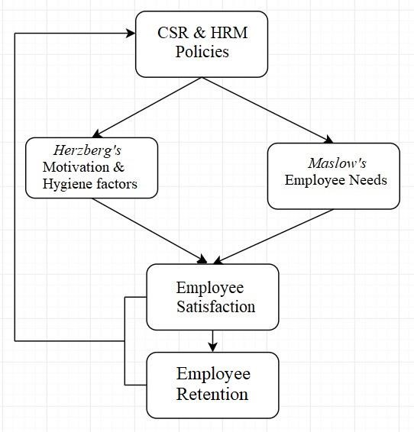
Figure 2.7 – Conceptual Framework

CHAPTER 03 - METHODOLOGY
This section of the thesis contains a description of the chosen methodology for the study. The scientific approach will be presented and explained, followed by further details of the selection of respondents, how the survey was conducted and what method was used for the analysis.
Lastly, the methodological criticism and the limitations will be presented.

3.1 Research Design
The Research-Design is the general plan of what the researcher will do to answer the research question (Saunders et al., 2009). This research has been designed according to the “onion model'' which was explained by Saunders et al. (2009). The model is named the "onion model" because of its shape. The model has six layers and to get the maximum output of this model, it is essential to start from the outer layer to the inner layer. Therefore, the research design of this study is based on these layers as shown in Figure 4.1
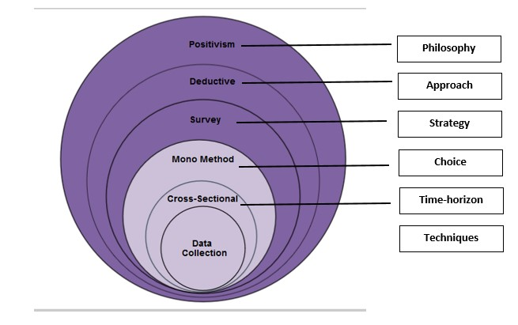

Figure 3.1 - The onion model (based on Mark Saunders, Philip Lewis and Adrian Thornhill (2008), cited in Saunders et al., 2009)
The layers are representing the process of research such as philosophies, approaches, strategies, choice of method(s), time horizons, and techniques (Saunders, et al., 2009).
The research philosophies’ overarching term relates to the development of knowledge and the nature of that knowledge (Saunders et al., 2009). Therefore, it is essential to understand the philosophical paradigms to design proper research. The authors used “Positivism” as the philosophy of this study. Moreover, the “Deductive Approach” was chosen as the research approach by authors as deduction owes more to positivism (Saunders et al., 2009).
The authors conducted a “Survey”, as the survey strategy is usually associated with the deductive approach (Saunders et al., 2009). The survey strategy is perceived as authoritative by academics in general and is both comparatively easy to explain and to understand (Saunders et al., 2009). Further, the authors made the choice to use the “mono method”, which allows using a single data collection and analysis method. Therefore, the authors intended to use the quantitative method where the survey strategy allows the collection of quantitative data. The quantitative data can be analysed using descriptive and inferential statistics (Saunders et al., 2009).
Moreover, since this study is academic research, the authors shall be bound by the specific and limited time period. This snapshot time horizon is called “Cross-sectional” (Saunders et al., 2009). Cross-sectional studies often employ the survey strategy (Saunders et al., 2009). In the final layer of the onion model, the authors chose “Rating questions” to collect data. Rating Questions most frequently use the Likert-style rating scale in which the respondent is asked how strongly she or he agrees or disagrees with a statement or series of statements (Saunders et al., 2009). However, the authors further described all steps in detail in the following chapters.

3.1.1 Research Philosophy - Positivism
According to Saunders et al., (2009), Epistemology concerns what constitutes acceptable knowledge in a field of study. Further, epistemology can also be described as positivism (Bryman & Bell, 2011). Hence, Saunders et al., (2009) stated that it is perfectly possible to adopt some of the characteristics of positivism into researches, for example, hypothesis testing, or using data originally collected in in-depth interviews or questionnaires.
Saunders et al., (2009) also emphasize that quantifiable observations lend themselves to statistical analysis because only observable phenomena can provide credible data and facts. However, positivism intends to generalize findings, by discovering data and facts, when observing a social reality (Saunders et al., 2012 as cited in Rödig & Zalud, 2019). This social reality, which in the case of this thesis is the one reality, where CSR leads to employee retention, can be observed by gathering larger samples whilst conducting surveys.

3.1.2 Research Approach - Deductive Approach
The study is mainly based on the deductive (scientific) approach, and therefore, it is common for outlines of the main steps of quantitative research to suggest that a hypothesis is deduced from the theory and is tested (Bryman and Bell, 2015). But quantitative research does not always entail the specification of hypothesis, and instead, theory acts loosely as a set of concerns in relation to which the business researchers collects data (Bryman and Bell, 2015). The specification of a hypothesis to be tested is particularly likely to be found in Experimental researches (Bryman and Bell, 2015). Hence, hypotheses do not test in this study and the data obtained through the cross-sectional research design in the form of a survey will be used for wider generalization. The findings will be compared to previous research.
As the authors take the reality of their assumption (CSR leading to employee retention) for granted, while following a positivistic approach, a survey seemed the right tool to conduct research. The authors hereby acted as neutral observers and had no chance to intervene, as the survey, which was held, was answered online. This leads to higher objectivity and quantifiable results as there is little to no room for interpretation, which makes it easier to generalize the results.

3.1.3 Research Strategy - Survey
A quick introduction of the authors and of their field of research was named and explained ahead of the survey questions, in order for the respondents to familiarize themselves with the subject. The questions in the survey are based on previous research papers regarding employee satisfaction and employee retention. They were adapted to the presented theories to match the needs of this study. The questions were formed into two different categories, starting with questions about resulting employee satisfaction through different internal CSR and HRM practices, and ending with questions about the overall level of satisfaction and the intention to stay (See appendix 1, for the survey questions). Specific questions were chosen in order to analyse Maslow’s and Herzberg’s Theories (see Operationalization).
Rating questions most frequently use the Likert-style rating scale in which the respondent is asked how strongly she or he agrees or disagrees with a statement or series of statements (Saunders et al., 2009).
All questions, excluding the background questions, can be answered on a five-point Likert-type scale, ranging from 1 (‘strongly disagree’) to 5 (‘strongly agree’), meaning that closed questions were used, where personal answers are not permitted. One of the advantages of using closed questions is that they can be pre-coded, thus turning the processing of data for computer analysis into a fairly simple task (Bryman and Bell, 2015). Altogether 18 questions were prepared while the survey took approximately five minutes to answer.
A translation of the survey was conducted into English, Swedish and German, in order to make it easier for the respondents to understand and answer the questions. As the focus of this thesis lies on general employee satisfaction and retention intention, the survey was open for respondents around the globe. The country of origin or in which country respondents are working, was hereby not considered.
Before the survey was sent out to all possible respondents, the questions were pilot tested by close family and friends of one of the authors. This gave the possibility to adapt and improve some questions which may not have been applicable or understandable to all respondents. After receiving feedback, minor changes were made to two questions before sending the survey out.

3.1.4 Choice of Method - Quantitative Data
The main objective was hereby to obtain quantitative data, which is numerically measurable to draw conclusions and to generalize. The findings are intended to be transformed into descriptive information. The minimum amount of data to obtain was 40 according to the authors’ supervisor, but 100 respondents was the recommended amount, for better generalization. Another criterion was the minimum age of 18 years, which is necessary according to a lecture about quantitative research design. After a period of nine days, the authors managed to maintain 135 respondents.
The authors send out their survey to three different multinational enterprises within Västerås. Due to unforeseeable external circumstances, which lead to the outcome that none of the organizations were able to answer the survey, the authors started to use convenience sampling. Accessible respondents were therefore found within the authors’ environment. The authors' friends and previous colleagues were asked to answer the survey and to send it on to others that are actively and mainly working. Therefore, the authors send a link of the survey to respondents on either Whatsapp or Facebook Messenger, which was then, in some cases, transferred to further respondents, that are not directly related to the authors. This leads to a high amount of data within a short amount of time. Students were not asked to answer the survey as the focus of this research lies on employees.
According to Bryman and Bell (2011), it is important that the respondent’s personal data will be treated with caution, and only used for the purpose of this study. The purpose of the study and that answers will remain anonymous, was therefore clearly stated at the beginning of the survey, to confirm that all personal data will be treated with caution. Background questions concern age, gender, position, the industry in which the employer is active, the division, and the amount of time the employee has been working for the employer.

3.1.5 Time Horizon - Cross-Sectional
The ‘snapshot’ time horizon called the cross-sectional study and Cross-sectional studies often employ the survey strategy (Saunders et al, 2009). Since the given time period is limited, the authors decided to choose cross-sectional which means the study of a particular phenomenon at a particular time (Saunders et al, 2009). And it is expected to investigate the relationship between CSR, employee satisfaction, and employee retention within the timeframe.

3.1.6 Techniques - Collecting theories & data
As this study is based on a deductive approach, both primary and secondary data were gathered for this research. Further, literature & theories of this thesis are based on well-known theories. Concepts were found through scientific articles, which will then be used to discuss the newly gathered primary data.
APA referencing style has been used for references and in-text citations for all literature & secondary sources.

3.1.6.1 Literature & Theories
The Keywords used for this study are HRM, CSR, employee retention, and employee satisfaction. Scientific articles were used for this thesis, in order to understand concepts and theories in the chosen field. These were found on Google Scholar as well as in the databases of Mälardalen University. Further, several older references are included in the literature review, which have not been modified.

3.1.6.2 Secondary Data
The secondary data used for this thesis was found on the Internet. Web articles, newspaper entries, blog entries, and companies’ websites were used to gather general knowledge in order to understand the current context towards the research topic.

3.1.6.3 Primary Data
Primary data is generally gathered as first-hand experiencing data. The authors of this study used the “Survey” strategy to gather primary data. The survey strategy is usually associated with a deductive approach that allows to collect quantitative data which can be analysed quantitatively by using descriptive and inferential statistics (Saunders et al., 2009).
Convenience sampling was the chosen method to gather the primary data.

3.1.6.4 Operationalization
Questions were formed and adapted in order to form variables that fit to the theories and concepts presented in the literature review.

Question | Variable | Type of  Scale | Items Used | Adapted from
Q 1 | Workspace Design | 5-Point  Likert  Scale | Employee Satisfaction,  CSR/HRM policy,  Physiological Needs,  Hygiene Factor | Zhu et al., 2014
Q 2 | Salary | 5-Point  Likert  Scale | Employee Satisfaction,  CSR/HRM policy,  Safety Needs,  Hygiene Factor | Lee & Chen, 2017

Q 3 | Work-LifeBalance | 5-Point  Likert  Scale | Employee Satisfaction,  CSR/HRM policy | Turban &  Greening, 1997 as cited in Barakat et al., 2016
Q 4 | Employer Support | 5-Point  Likert  Scale | Employee Satisfaction,  CSR/HRM policy | Zhu et al., 2014
Q 5 | Meetings for information exchange | 5-Point  Likert  Scale | Employee Satisfaction,  CSR/HRM policy | Lee & Chen, 2017
Q 6 | Teamwork | 5-Point  Likert  Scale | Employee Satisfaction,  CSR/ HRM policy,  Love Needs,  Hygiene Factor | Lee & Chen, 2017
Q 7 | Happiness | 5-Point  Likert  Scale | Employee Satisfaction,  CSR/HRM policy | Lee & Chen, 2017
Q 8 | Feeling of  Contribution | 5-Point  Likert  Scale | Employee Satisfaction,  CSR/HRM policy,  Motivation Factor | Vlachos et al., 2013
Q 9 | Supervision  (Allowance for  Questions) | 5-Point  Likert  Scale | Employee Satisfaction,  CSR/HRM policy,  Hygiene Factor | Lee & Chen, 2017
Q 10 | Space for new ideas | 5-Point  Likert  Scale | Employee Satisfaction, CSR/HRM policy | Vlachos et al., 2013

Q 11 | Participation | 5-Point  Likert  Scale | Employee Satisfaction,  CSR/HRM policy,  Self-Esteem Needs | Turban &  Greening, 1997 as cited in Barakat et al., 2016
Q 12 | Support for Growth | 5-Point  Likert  Scale | Employee Satisfaction,  CSR/HRM policy | Harter et al., 2002 as cited in Barakat et al., 2016
Q 13 | Supervision  (Clearness of  Instructions) | 5-Point  Likert  Scale | Employee Satisfaction,  CSR/HRM policy | Vlachos et al., 2013
Q 14 | Stress Level | 5-Point  Likert  Scale | Employee Satisfaction,  CSR/HRM policy | Zhu et al., 2014
Q 15 | Usage of skills | 5-Point  Likert  Scale | Employee Satisfaction,  CSR/HRM policy | Lee & Chen, 2017
Q 16 | Options for Growth | 5-Point  Likert  Scale | Employee Satisfaction,  CSR/HRM policy,  Self-Actualization Needs,  Motivation Factor | Vinerean et al., 2013a
Q 17 | Long-term career plans | 5-Points  Likert  Scale | Employee Retention Intention, Success of internal CSR | Lee & Chen, 2017
Q 18 | Willingness to recommend employer | 5-Points  Likert  Scale | Employee Satisfaction, Success of HRM | Lee & Chen, 2017
Table 3.1.6.4 - Operationalization of variables

3.1.7 Data analysis and presentation

As previously stated, was the survey distributed in three different languages. The questions were hereby translated, but the answers, excluding the background questions, do not have to be translated. The 5-point Likert-type scale was used in all surveys, which made it easier to connect the three surveys for the analysis. The authors used Microsoft Excel 2016 & IBM SPSS analytical software to analyse and present data.
Diagrams are among the most frequently used methods of displaying quantitative data (Bryman & Bell, 2015). Hence, Pie charts and tables will be presented to visualize the demographic results. The main advantage of using pie charts & bar charts is that they are relatively easy to understand to the readers.
The descriptive data was analysed using frequency table and bar charts to present the data within it. The frequency tables provide the number of people and the percentage belonging to each of the categories, for the variable in question (Bryman & Bell, 2015).
A descriptive analysis was conducted, thereby comparing the demographic backgrounds of the respondents and their given answers to the questions. The different industries the respondents work in, the different age groups and, the years working for the current employer, will, therefore be analysed in detail. The descriptive analysis intends to identify and explain possible patterns that may arise among different groups, regarding HRM and internal CSR and their effect on employee satisfaction and retention.

3.2 Method Criticism: Reliability and Validity
Although the terms “Reliability” and “Validity” seem to be almost like synonyms, they have quite different meanings in relation to the evaluation of measures of concepts (Bryman & Bell, 2015). Reducing the possibility of getting the answer wrong means that attention must be paid to two emphases on research design: reliability and validity (Saunders et al., 2009). Therefore, the authors of this study intended to conduct proper scientific research by fairly treating these concepts to minimize the bias and errors of the study.

3.2.1 Reliability
Reliability refers to the extent to which data collection techniques or analysis procedures will yield consistent findings (Saunders et al., 2009). Therefore, reliability refers to the consistency of the measurement of a concept (Bryman & Bell, 2015). Furthermore, referring to Saunders et al. (2009), it is understandable that proper research should minimize subject or participant error, subject or participant bias, observer error, and observer bias to keep the reliability of the study.
To minimize the participant error of this study, the authors managed to send the questionnaire to participants during the weekends. The authors could give them enough time to send the responses since the research is well-planed and continuing according to the timeline. Further, the method is bias-free because the author allowed respondents to respond without any hesitation as answers were given anonymously. The survey was highly structured, serving all participants equally. This allows the authors to minimize the observer errors of the research. And it is also expected to treat all responses similarly since this leads to minimize observer bias of this research.

Furthermore, Bryman and Bell (2015) stated the concept of “internal reliability” which can be used as a fair treatment to assure reliability. According to Bryman and Bell (2015), it is necessary to be assured that all indicators guarantee consistency. Hence, the authors used the
5-points Likert scale measure to each question and further fixed the middle point as “neutral” to allow neutral responses. This allowed the authors to maintain ethical and reliable treatment as they were using the same scale. However, responses can vary due to respondents’ attitudes and cultural background.

To distinguish between the different backgrounds of the respondents, the authors chose to form smaller groups regarding the background data collected. Examples are the groups ‘Banking and
Finance’ and ‘IT’, which were separated instead of forming one big group called ‘Services’. These smaller groups were formed in all categories of the background questions. With this approach, the authors intend to have a more consistent descriptive analysis, when comparing the answers of respondents coming from different industries, different age groups and years of working for the current employer.

3.2.2 Validity
Validity is concerned with the integrity of the conclusions that are generated from a piece of research (Bryman & Bell, 2015). Validity is further concerned with whether the findings are really about what they appear to be about (Saunders et al., 2009). In general, the outcome of the research should have the ability to fulfil the objective of the study.
The use of references in the appendix gives the authors a legitimate reason to ask the specific questions and gives the study overall more validity. The pilot-testing, which was conducted to see eventual weaknesses in the formulation of the questions, leads to further validity. A theoretical triangulation was conducted, as more than one theory was used to interpret the presented research phenomenon. Due to the fact that three authors are a part of this thesis, an investigator triangulation is further conducted, which strengthens the validity of this study.
As the focus lies on employees from different demographic backgrounds, generalizability, and validity is further strengthened. Sometimes, external validity is referred to as “Generalizability” (Saunders et al., 2009). The results of the research should reflect the real world. Hence, the authors always took logical steps in the entire data collecting process to assure the validity of the study. Further, peer-reviews were held, and comments were given about each section of this thesis. As our respondents come from different backgrounds, data triangulation, which is used, makes it easier to generalize the results.

3.3 Limitations
This study comes with some notable methodological limitations. Firstly, the secondary data collected dates back until 1996. This is due to the well-known theories which were used and adapted to the research presented. The authors found the chosen theories both in older and newer sources and research articles. Several parts of the references retrieved, can be categorized as older research, while dating back for up to twenty-four years. This secondary data can be seen as outdated and irrelevant.
The primary data, gathered through a survey by using convenience sampling, further gives room to criticize. The survey was not only distributed directly from the authors to the respondents but transferred further. As the survey was sent on to further respondents by the initial respondents, the sample characteristics were not coordinated by the authors. The initial respondents, which the authors knew and chose to include in their sample, were therefore adjoined by a number of random respondents, whose backgrounds were mostly unknown. In one case, a family member of one of the authors sent the survey further on to her colleagues, which resulted in the entire company answering the survey. Bias can therefore arise. Another limitation is the inclusion of previous colleagues, who were asked to answer the survey. As one of the authors knows the company’s culture in which a part of the respondents is working, bias can further arise.

Lastly, did the chosen theory of Maslow’s Pyramid receive a certain amount of criticism. The criticism includes, among other points, that Maslow's pyramid of needs assumes that all employees are having the same needs, and also that all situations are the same (Basset-Jones & Lloyd 2004, p. 961 as cited in Kaur, 2013). The usage of such a theory can further affect the credibility of the study.

CHAPTER 4 - RESULTS
This section of the thesis provides insights from the survey, presented in a descriptive way, by using charts and graphs to visualize the findings to the reader.

4.1 Respondents Percentage
The authors sent the questionnaire to 160 people, out of which 135 respondents replied while 25 respondents did not reply. The percentage of total respondents and non-respondents can be demonstrated as follows,
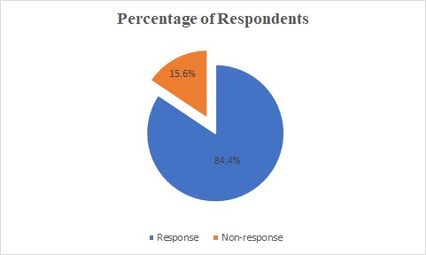
Figure 4.1.1 - Respondents Percentage

4.2 Demographic Analysis

4.2.1 Gender
The cross-sectional survey was sent out to friends, family and previous colleagues of the authors and led to a total of N=135. The total number of women answering the survey is 58 (approx. 43.0%), with the total of men being 77 (approx. 57,0%) answered.
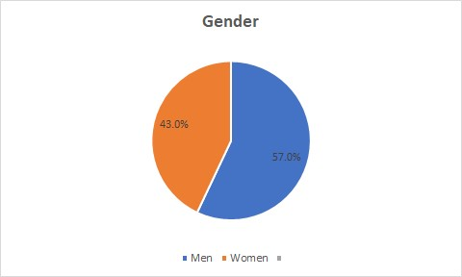
Figure 4.2.1 - Gender

4.2.2 Age of respondents
Most of the respondents (62,2%) are between 25 and 34 years old, followed by 17,0% being between 18 and 24 years old. The third biggest group (12,6%), is between 35 and 44 years old, while only 5,2% stated being between 45 and 54, and 3,0% being over 55. The major part of respondents are therefore younger generations.
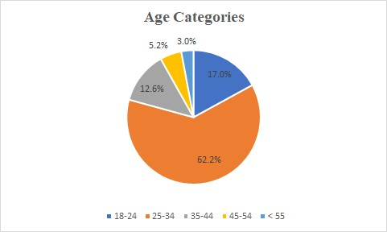
Figure 4.2.2 - Age Categories

4.2.3 Work Experience at the Current Employer
The respondents have had a fresh start at their current employer, being employed for under a year (14,8 %), or for rather short periods of 1-3 years (40,0%). Medium periods of 4-9 years (29,6%), were common as well. Longer periods between 10-14 years (6,7%), 15-20 years (5,2%) and over 20 years (3,7%), were less common.
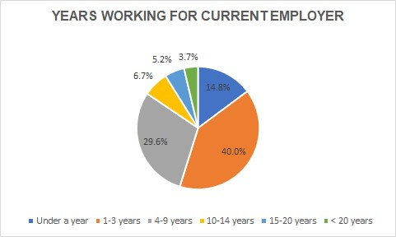
Figure 4.2.3 - Years working for current employer

4.2.4 Industry
The respondents work in highly diverse types of industries. The most common industries are Banking & Finance (29,6%) as well as IT (11,9%), followed by Health and Social Services (11,1%) and Hospitality (10,4%).
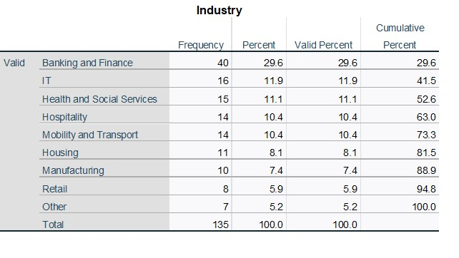
Table 4.2.4 - Industries

4.2.5 Department
Regarding the Department, the authors can see a clear tendency towards Sales (17,8%) and Finance (14,1%). Further common departments are Administration (13,3%) and Production (9,6%).
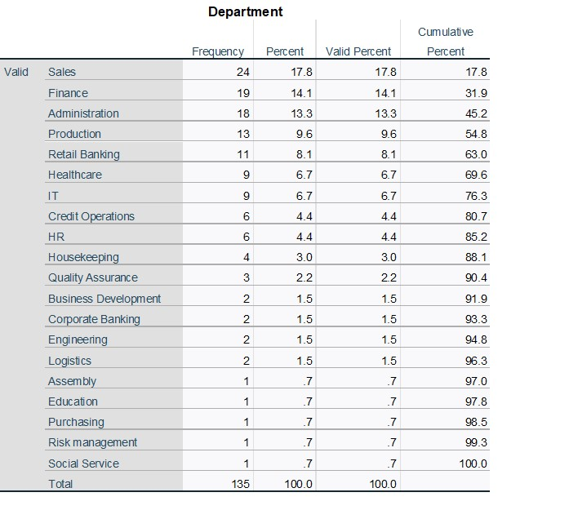
Table 4.2.5 - Department

4.2.6 Position
The main positions match the industries while being either Executives (35.6%) or Assistants (8,9%), being followed by Junior Executives (6,7%) and Sales Coach (6,7%).
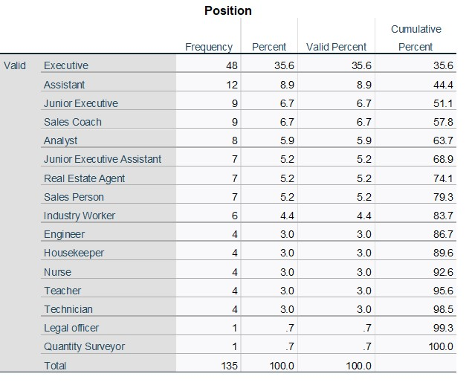
Table 4.2.6 - Position

4.3 Presentation of the research findings
In the following part of the thesis, the answers to the survey questions regarding employee satisfaction and retention will be presented in the form of bar charts. Please refer to Appendix 2 for further descriptive statistics, in the form of frequency tables.
Q1 - I am satisfied with the current working environment (break room, office design, coffee
machine, etc.)
A total of 104 (77.0%) respondents of the population have agreed or strongly agreed with the above statement, while 24 (17.8%) respondents remain neutral, and 07 (5.2%) respondents disagreed or strongly disagreed.
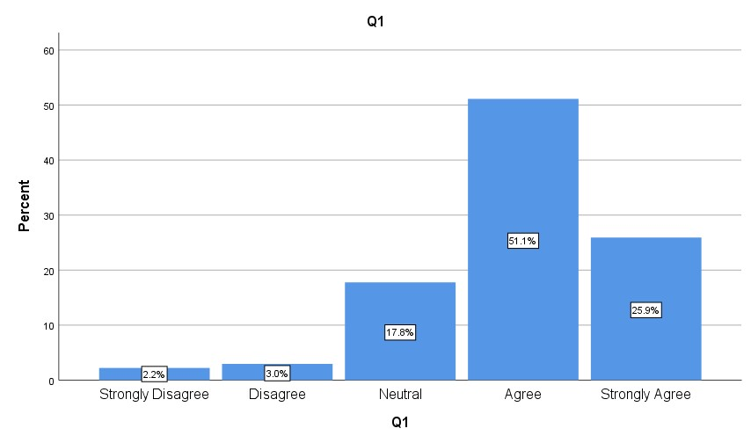
Figure 4.3.1 - Responses Analysis
Q2- My company offers a fair salary
A total of 80 (59.3%) respondents of the population have agreed or strongly agreed with the above statement while 27 (20.0%) respondents remain neutral and 28 (20.7%) respondents disagreed or strongly disagreed.
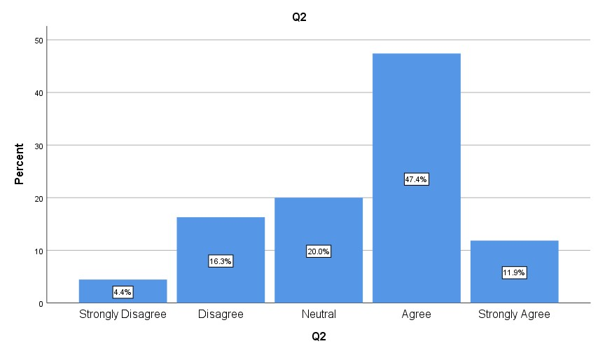
Figure 4.3.2 - Responses Analysis
Q3 - I feel like having a work-life balance (vacation, allowance for days off due to personal
issues, etc.)
A total of 81 (60.0%) respondents of the population have agreed or strongly agreed with the above statement while 34 (25.2%) respondents remain neutral and 20 (14.8%) respondents disagreed or strongly disagreed.
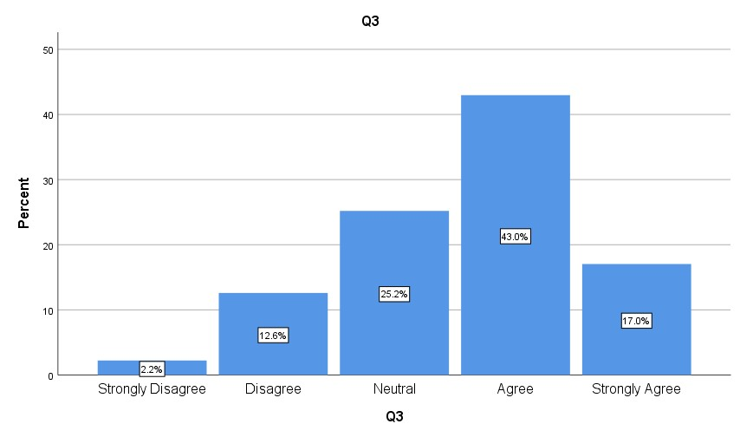
Figure 4.3.3 - Responses Analysis
Q4 - I feel like I am receiving the support I need from my company (mental and physical
health care, consulting, etc.)
A total of 77 (57.0%) respondents of the population have agreed or strongly agreed with the above statement while 37 (27.4%) respondents remain neutral and 21 (15.6%) respondents disagreed or strongly disagreed.
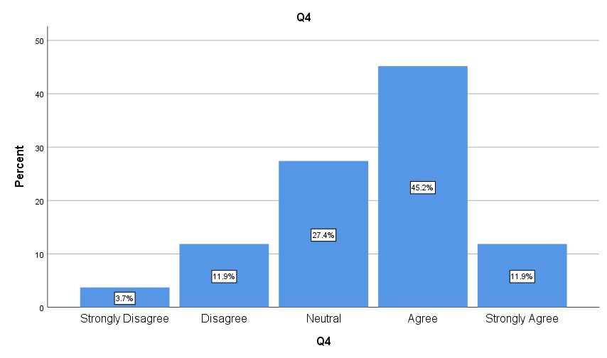
Figure 4.3.4 - Responses Analysis
Q5- My company offers meetings for an exchange of information and complaints A total of 80 (59.3%) respondents of the population have agreed or strongly agreed with the above statement while 29 (21.5%) respondents remain neutral and 26 (19.3%) respondents disagreed or strongly disagreed.

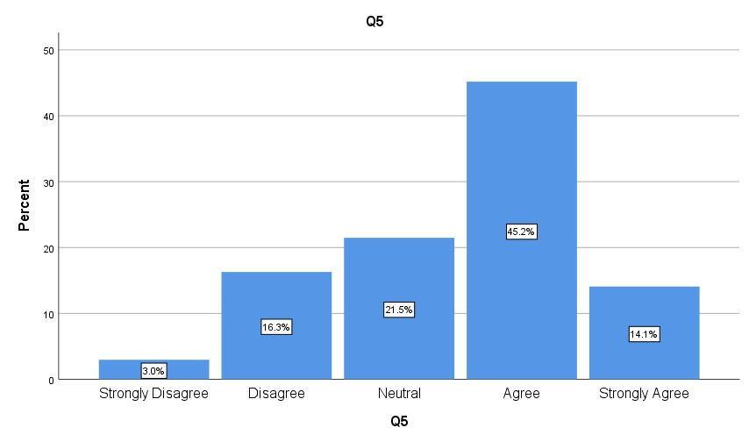
Figure 4.3.5 - Responses Analysis
Q6- My company embraces teamwork for example by organizing different activities/projects A total of 92 (68.1%) respondents of the population have agreed or strongly agreed with the above statement while 21 (15.6%) respondents remain neutral and 22 (16.3%) respondents disagreed or strongly disagreed.
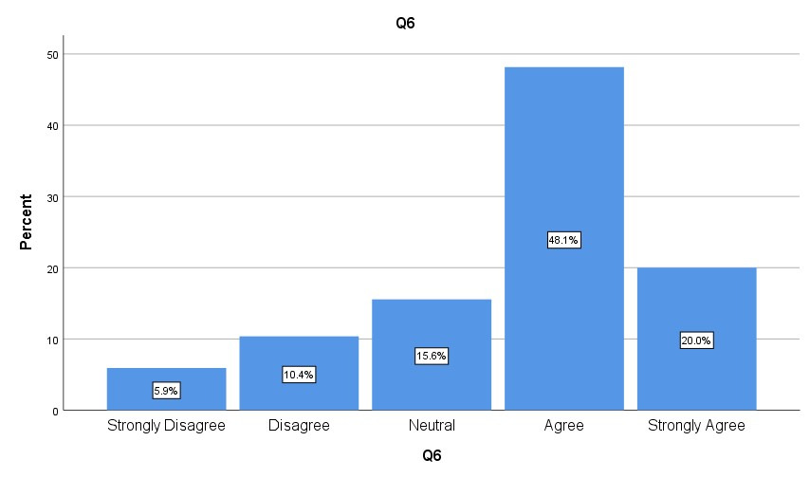
4.3.6
Q7- I feel happy to come to work
A total of 93 (68.9%) respondents of the population have agreed or strongly agreed with the above statement while 34 (25.2%) respondents remain neutral and 8 (6.0%) respondents disagreed or strongly disagreed
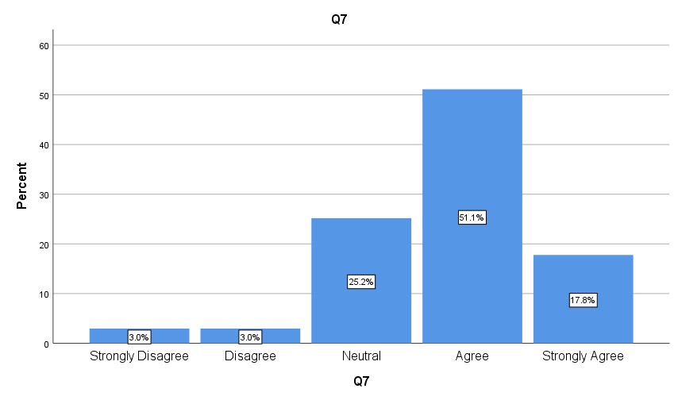
Figure 4.3.7 - Responses Analysis
Q8- I feel that I am contributing to something meaningful at work A total of 106 (78.4%) respondents of the population have agreed or strongly agreed with the above statement while 17 (12.6%) respondents remain neutral and 12 (8.9%) respondents disagreed or strongly disagree.
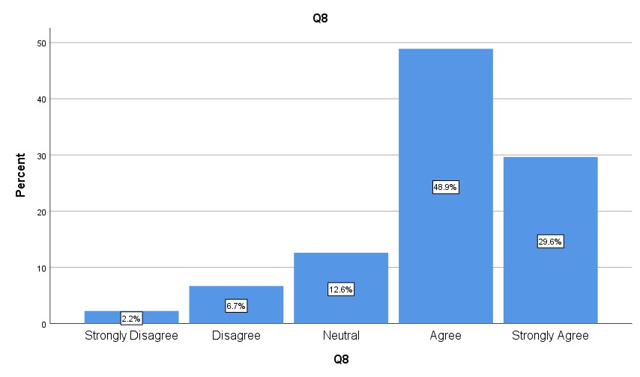
Figure 4.3.8 - Responses Analysis
Q9- My supervisor is available for questions
A total of 115 (85,2%) respondents of the population have agreed or strongly agreed with the above statement while 9 (6.7%) respondents remain neutral and 11 (8.2%) respondents disagreed or strongly disagreed.
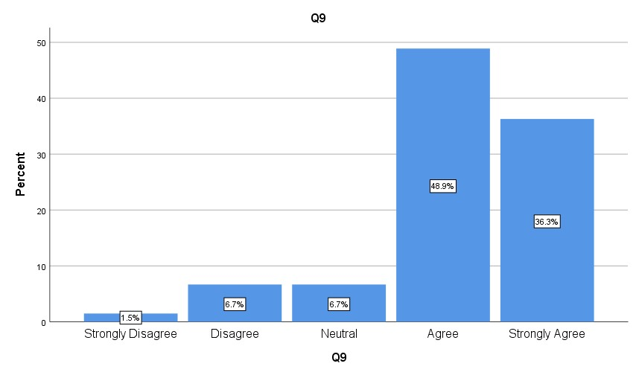
4.3.9
Q10- My company always welcomes new ideas
A total of 85 (63.0%) respondents of the population have agreed or strongly agreed with the above statement while 34 (25.2%) respondents remain neutral and 16 (11.8%) respondents disagreed or strongly disagreed
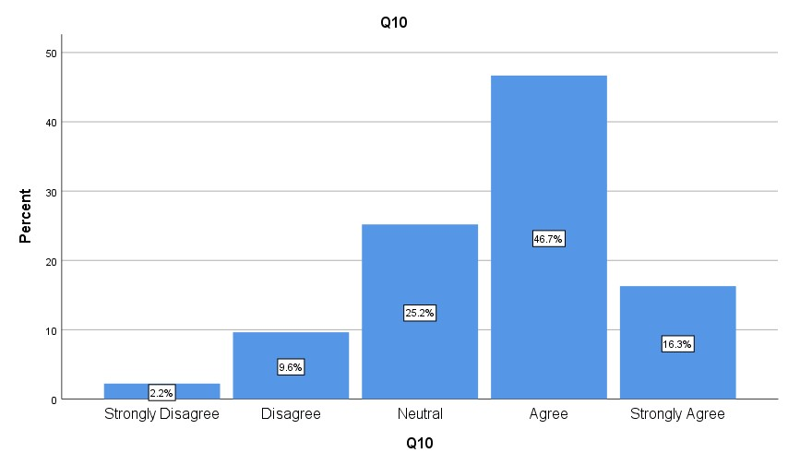
Figure 4.3.10 - Responses Analysis
Q11- I am given the opportunity to express myself
A total of 102 (75.5%) respondents of the population have agreed or strongly agreed with the above statement while 21 (15.6%) respondents remain neutral and 12 (8.9%) respondents disagreed or strongly disagreed
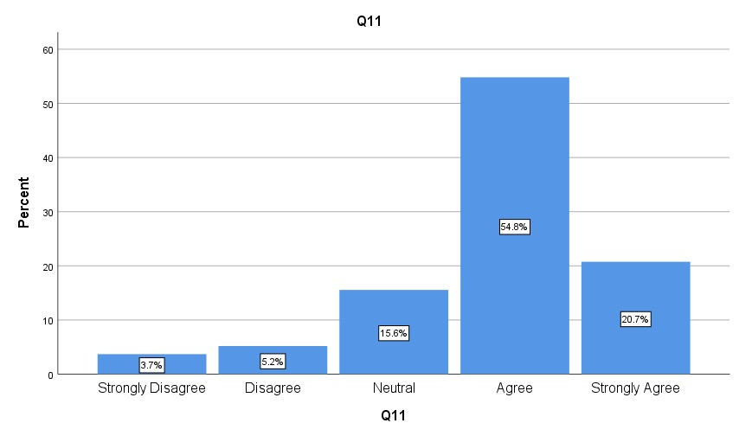
Figure 4.3.11 - Responses Analysis
Q12- I am given the support to pursue my ambitions A total of 79 (58.5%) respondents of the population have agreed or strongly agreed with the above statement while 43 (31.9%) respondents remain neutral and 13 (9.6%) respondents disagreed or strongly disagreed.
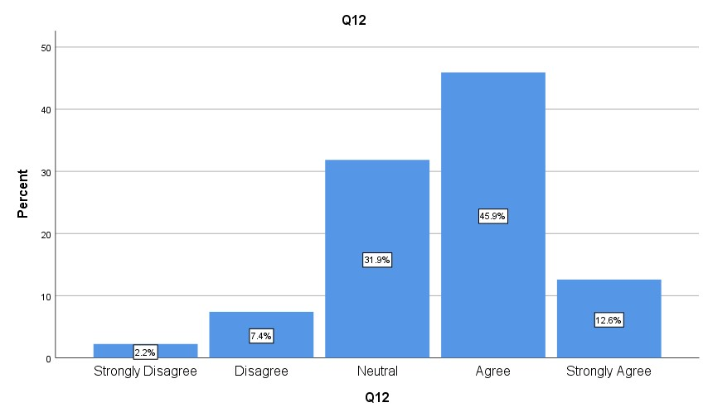
4.3.12
Q13- My supervisor provides clear instructions
A total of 96 (71.2%) respondents of the population have agreed or strongly agreed with the above statement while 25 (18.5%) respondents remain neutral and 14 (10.3%) respondents disagreed or strongly disagreed.
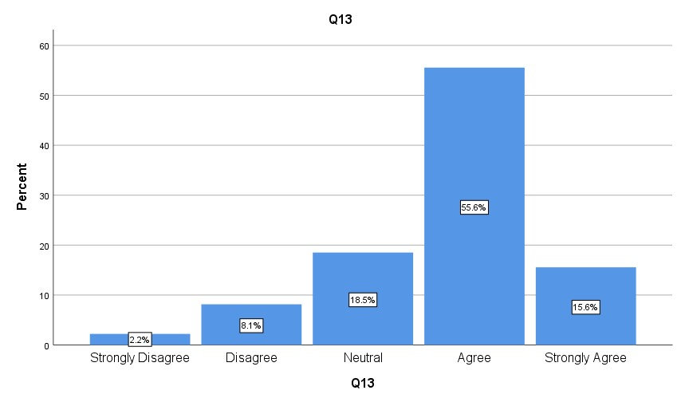
Figure 4.3.13 - Responses Analysis
Q14- I feel like I can handle my current workload
A total of 97 (71.9%) respondents of the population have agreed or strongly agreed with the above statement while 25 (18.5%) respondents remain neutral and 13 (9.6%) respondents disagreed or strongly disagreed.
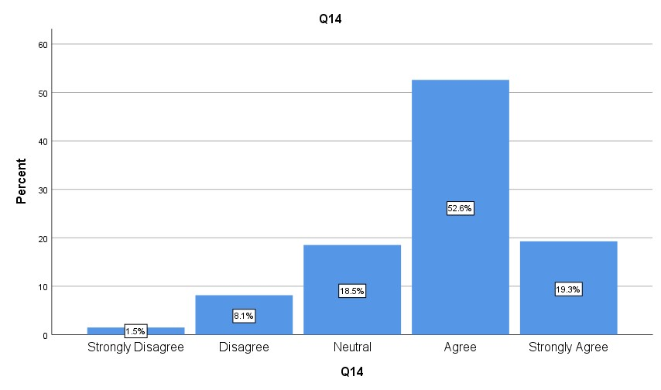
Figure 4.3.14 - Responses Analysis
Q15- I feel like I can use my skills
A total of 95 (70.4%) respondents of the population have agreed or strongly agreed with the above statement while 25 (18.5%) respondents remain neutral and 15 (11.1%) respondents disagreed or strongly disagreed.
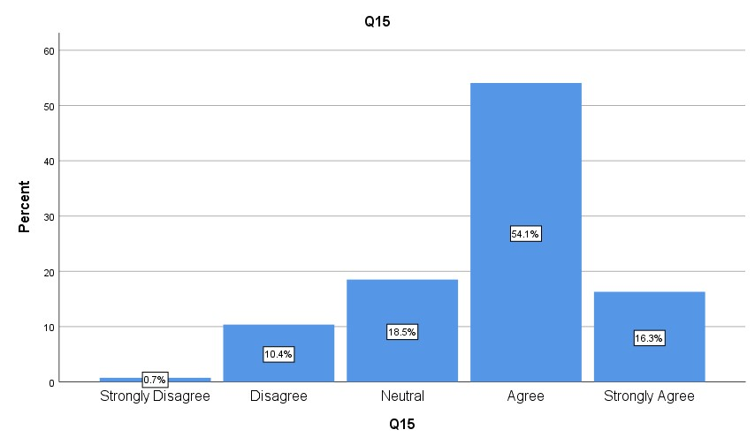
4.3.15
Q16- My company provides options for training & personal development A total of 85 (63.0%) respondents of the population have agreed or strongly agreed with the above statement while 33 (24.4%) respondents remain neutral and 17 (12.6%) respondents disagreed or strongly disagreed.
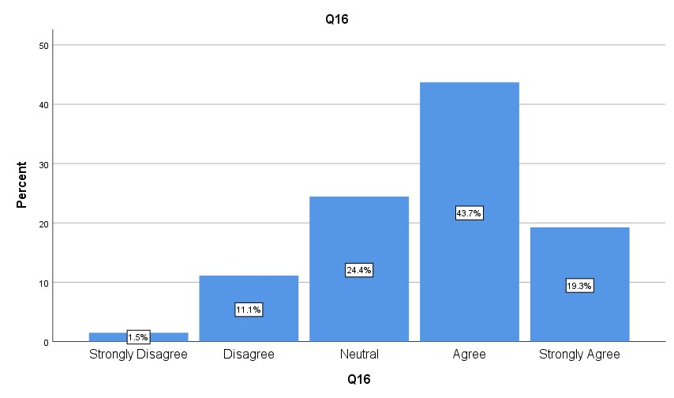
Figure 4.3.16 - Responses Analysis
Q17- I plan a long-term career in this company
A total of 71 (52.6%) respondents of the population have agreed or strongly agreed with the above statement while 27 (20.0%) respondents remain neutral and 37 (27.4%) respondents disagreed or strongly disagreed.

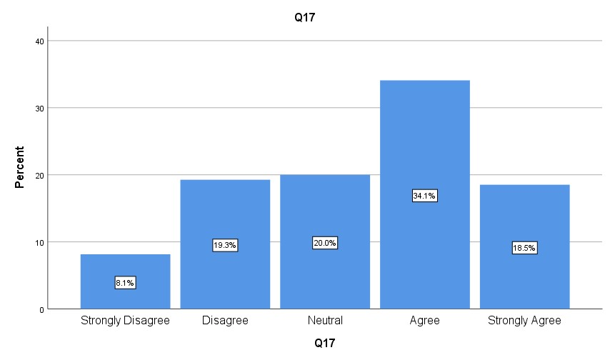
Figure 4.3.17 - Responses Analysis
Q18- I would recommend this company as an employer
A total of 99 (73.3%) respondents of the population have agreed or strongly agreed with the above statement, while 26 (19.3%) respondents remain neutral and 10 (7.4%) respondents disagreed or strongly disagreed.
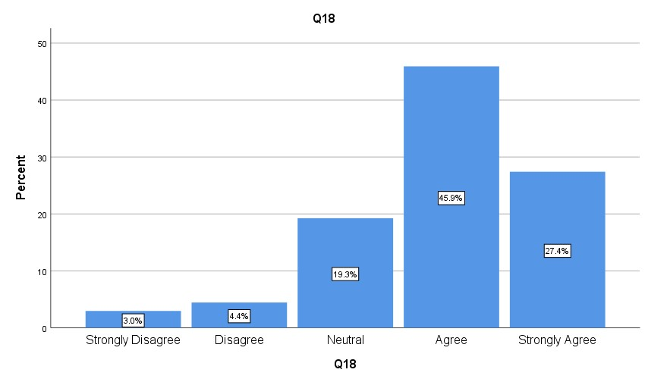
4.3.18 Responses Analysis

4.4 Comparative Analysis
The following comparative analysis introduces frequency tables, comparing the answers of three different demographic categories. The different categories include age, years working for the current employer, and industry. Specific questions were chosen that seem most crucial for the chosen theories.

4.4.1 Working environment
I am satisfied with the current working environment (break room, office design, coffee machine etc.)
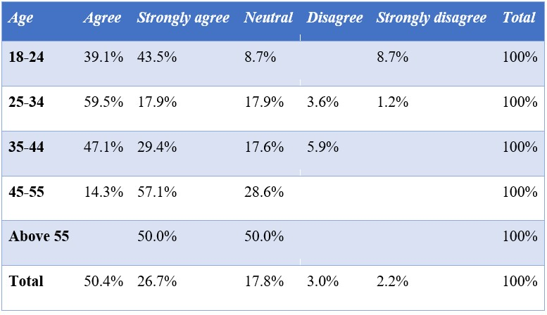
Table - 4.4.1.1 - Age * Q1 Cross-tabulation
18-24-year-old respondents, agree or strongly agree with the above statement to 82,6 %. Respondents between 25-34 years, answered either with Strongly Agree (17,9 %) or Agree
(59,5%). 35-44-year-old respondents agree or strongly agree, by forming a total of 76,5 %. 4554-year-olds form the biggest group which strongly agrees with the above statement (57,1%), while 14,3% agree and no one disagrees. For the smallest group, the above 55-year-olds, the statements are divided between strongly agreed (50%) and neutral (50%).

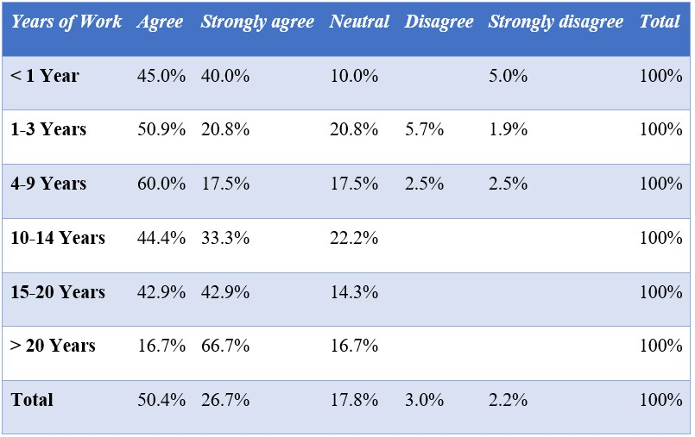
Table - 4.4.1.2 - Years working for current employer * Q1 Cross-tabulation
The respondents, who have been working for their current employer for under a year, strongly agree or agree with the above statement, forming a total of 85% of respondents. Of the respondents working for 1-3 years, 71,7% agree or strongly agree. Respondents working for 49 years mostly agree or strongly agree (77,5%), while 5% disagree or strongly disagree. Similar results exist for the groups working for 10-14, 15-20, and above 20 years as they mainly strongly agree or agree (77,7%; 85,8%; 83,4%). None of the respondents in these three groups disagrees or strongly disagrees.

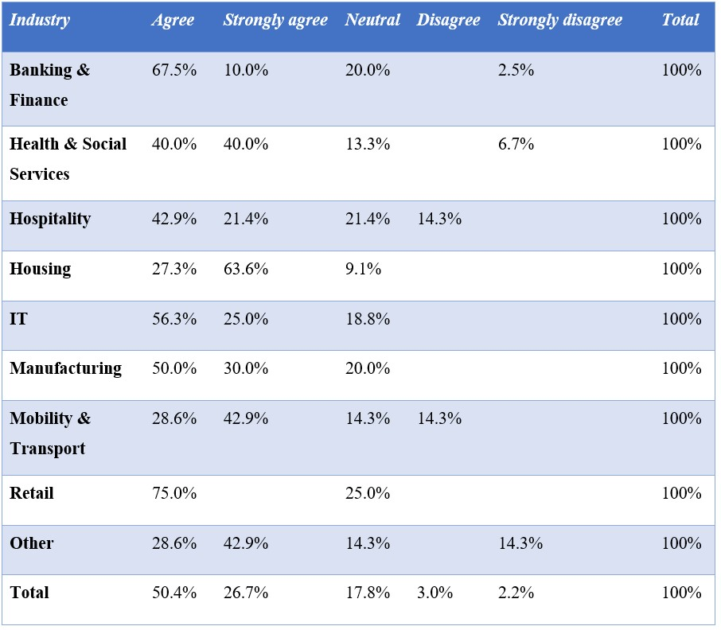
Table - 4.4.1.3 - Industry * Q1 Cross-tabulation
The respondents that mainly agreed or strongly agreed with the above statement have the backgrounds Housing (90,0), IT (81,3%), Health and Social Services (80%), Manufacturing (80%), Banking and Finance (77,5%) and Retail (75%). Respondents in these industries responded with over 75% either strongly agree or agree.
The most negative responses, where respondents either stated that they disagree or strongly disagree with the above statement, came from the backgrounds Mobility and Transport (14.3%), Hospitality (14,3%) and Others (14,3%). Nonetheless, do all industries rather raise positive answers.

.4.2 Salary
My company offers a fair salary
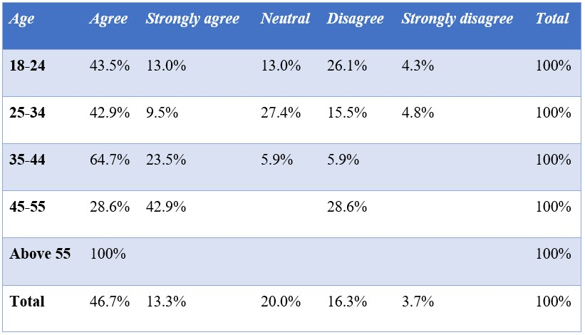
Table 4.4.2.1 - Age * Q2 Cross-tabulation
The respondents between 18-24 years agree or strongly agree with a total of 56,5%, while 30,4% disagree or strongly disagree. The respondents between 25-34 years agree or strongly agree with a total of 52,4 %, while 20,8% disagree or strongly disagree. 88,2% of 35-44-yearagree or strongly agree, while 5,9% disagree. 70,5% of the 45-54-year-old agree or strongly agree, while 28,6% disagree. None of them strongly disagrees or stays neutral. The above 55year-old respondents agree to 100%.
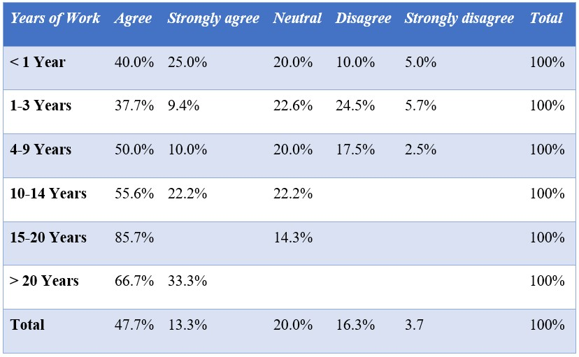
Table 4.4.2.2 Years working for current employer * Q2 Cross-tabulation
65% of respondents working for under a year, agree or strongly agree with the above statement, while 15% disagree or strongly disagree. Respondents working 1-3 years strongly agree or agree with 47,1%, while 30,2% disagree or strongly disagree. 60% of respondents working 4-9 years agree or strongly agree while 20% disagree or strongly disagree. None of the respondents working between 10-14 years disagrees or strongly disagrees with the above statement, while 77,8% of them agree or strongly agree. The group working 15-20 years either agrees (85,7%) or remains neutral (14,3%). Respondents working for their employer above 20 years, agree or strongly agree to 100%.
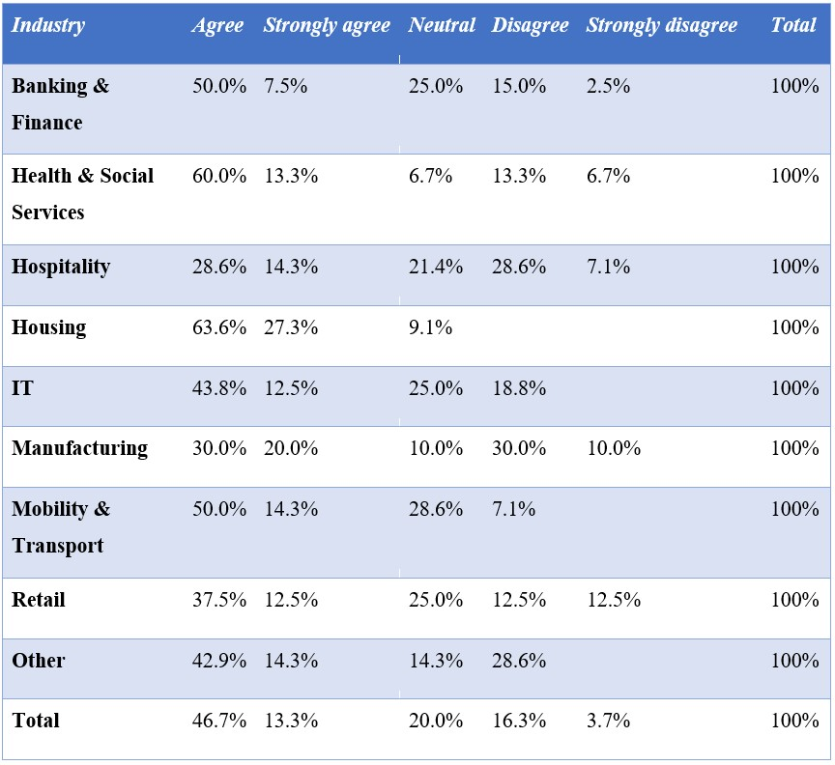
Table 4.4.2.3 - Industry * Q2 Cross-tabulation
The respondents being the most satisfied with their salary, have the backgrounds Housing (90,9%) and Health and Social Services (73,3%). The housing industry is the only industry in which none of the respondents disagree or strongly disagree. The industries being the least satisfied with their salary and therefore disagree or strongly disagree with the above statement are Manufacturing (40%), Hospitality (35,7%), Other (28,6%) and Retail (25%). In these industries, 25% or more of respondents disagree or strongly disagree with their current salary. Nonetheless, are there more respondents that agree or strongly agree with their given salary in all named industries.

.4.3 Teamwork
My company embraces teamwork for example by organizing different (entertaining)
activities/projects
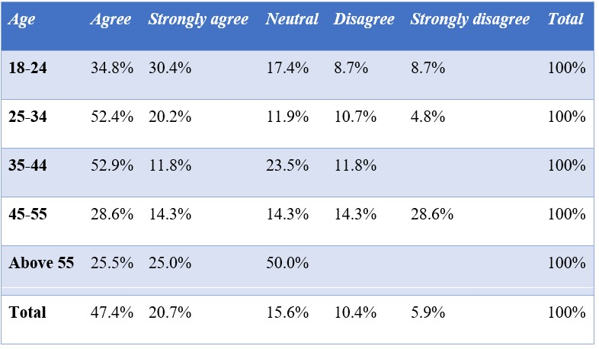
Table 4.4.3.1 - Age * Q6 Cross-tabulation
65,2% of the 18-24-year-old respondents agree or strongly agree with the above statement. 17,4% disagree or strongly disagree. 72,6% of the 25-34-year-olds agree or strongly agree. Of the 35-44-year-olds 64,7% agree or strongly agree, while 11,8% disagree. 42,9% of the 45-55year-olds agree or strongly agree, while the 42,9% disagree or strongly disagree. Of the above 55-year-olds, 50% agree or strongly agree, while 50% remain neutral.
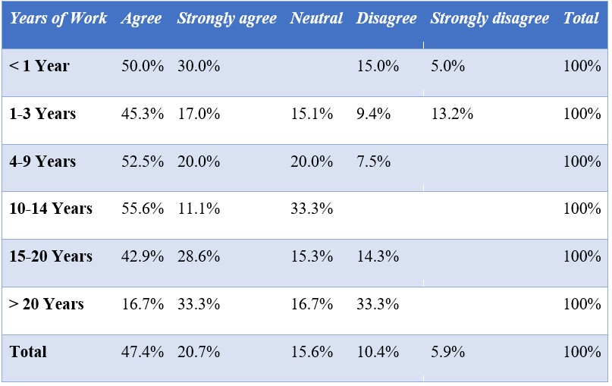
Table 4.4.3.2 Years working for current employer * Q6 Cross-tabulation
Respondents working for under a year, agree or strongly agree to 80%. The remaining 20% disagree or strongly disagree. From the respondents working 1-3 years, 62,3% agree or strongly agree, while 22,6% disagree or strongly disagree. 72,5% of respondents working for 4-9 years agree or strongly agree. 20% remain neutral and 7,5% disagree. The respondents working 1014 years agree or strongly agree with 66,7%. The remaining 33,3% remain neutral. 71,5% of respondents that have been working 15-20 years agree or strongly agree, while 14,3% disagree.
Respondents working over 20 years agree or strongly agree to 50%, while 33,3% disagree.
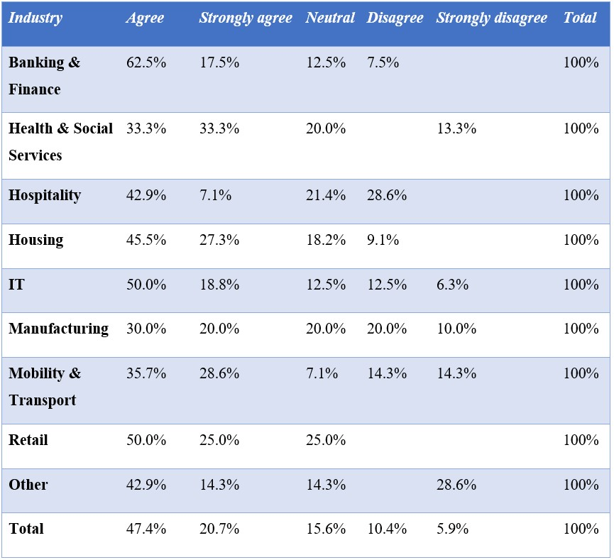
Table 4.4.3.3 - Industry * Q6 Cross-tabulation
The respondents which mainly answered with agree or strongly agree and therefore stated that teamwork is common within their work environment had the backgrounds Banking and Finance (78,9%) and Retail (75%) and Housing (72,8%). The respondents who stated that teamwork was uncommon within their work environment had the backgrounds Mobility and Transport, Hospitality and, Other. In each industry, 28,7% of respondents strongly disagree or disagree. The biggest group of respondents to disagree with the above statement had the background Manufacturing (30%), while 50% of respondents agreed or strongly agreed with the above statement. In all named industries, respondents mainly stated agree or strongly agree.

.4.4 Advancement & Responsibility
I feel that I am contributing to something meaningful at work.
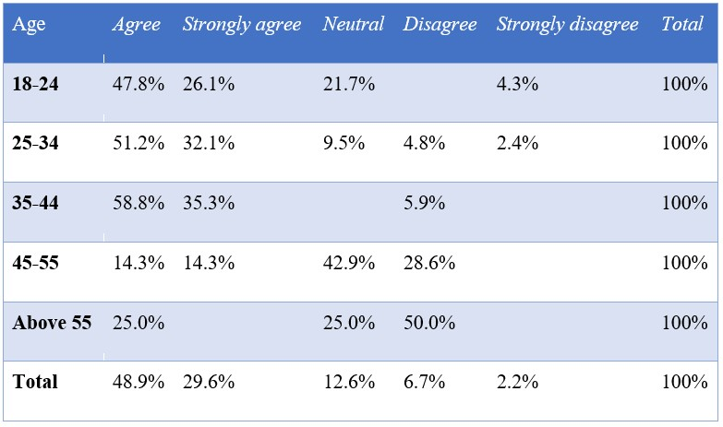
Table 4.4.4.1 - Age * Q8 Cross-tabulation
Of the 18-24-year-old respondents, 73.9% agree or strongly agree about contributing through their work, while 4.3% strongly disagree. 83,3% of the 25-34-year-old respondents agree or strongly agree, while 7,2% disagree or strongly disagree. Respondents between 35-44 years, agree or strongly agree to 94%. 28,6% of respondents between 45-54 years agree or strongly agree to the above statement, while 42,9% remain neutral and 28,6% disagree. Respondents above the age of 55 either agree (50%), remain neutral (25%) or disagree (25%).
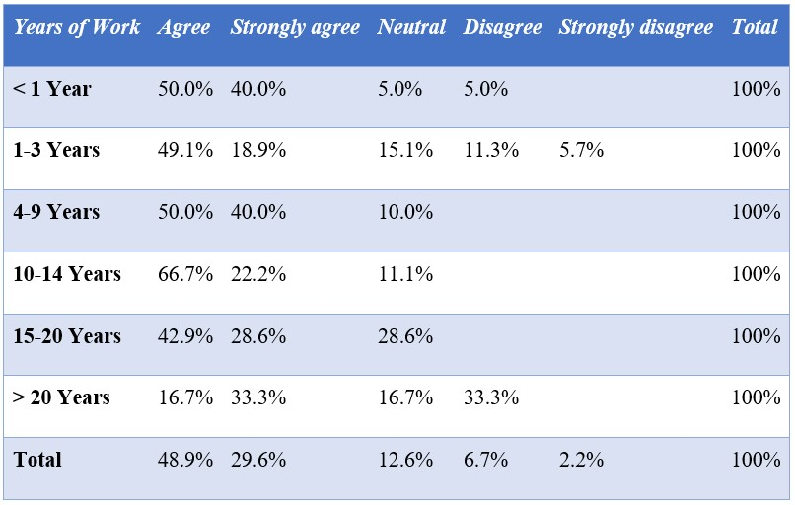
Table 4.4.4.2 Years working for current employer * Q8 Cross-tabulation
Respondents working for their current employer for under a year agree or strongly agree to a total of 90%. 68% of respondents working for 1-3 years agree or strongly agree, while 17% disagree or strongly disagree. Respondents working 4-9 years for their current employer agree or strongly agree (90%), while 10% remain neutral. Similar results can be found comparing the groups working 10-14 years and 15-20 years. No respondents within these three groups disagree or strongly disagree with the above statement. Respondents working above 20 years, agree or strongly agree (50%), while 33,3% disagree and 16,7% remain neutral.
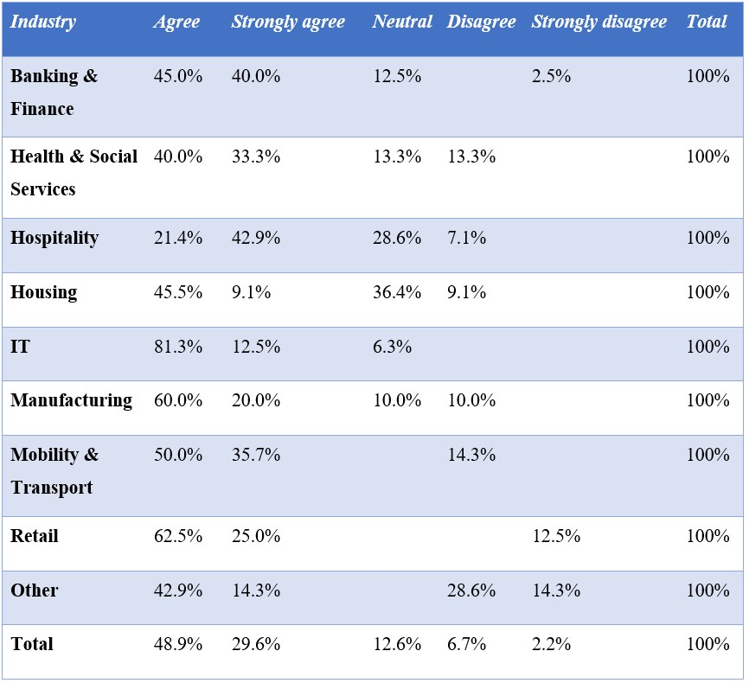
Table 4.4.4.3 - Industry * Q8 Cross-tabulation
The industries receiving the most positive responses are IT (93,8%), Mobility and Transport (87,5%), Retail (87,5%), Banking and Finance (83,7%) and Manufacturing (80%). Within these industries, respondents rather feel that they are contributing to something meaningful. The industries with respondents giving the most negative responses being either disagree or strongly disagree are Others (42,9%). The total of all negative responses is 8,9%.

.4.5 Supervision
My supervisor is available for questions
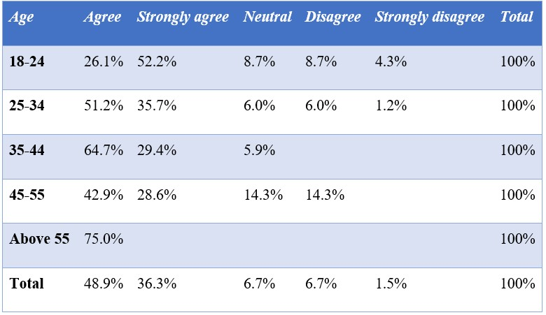
Table 4.4.5.1 - Age * Q9 Cross-tabulation
The above statement deals with employee satisfaction achieved through supervision. 78,3% of 18-24-year-olds agree or strongly agree. Similar results can be found for respondents between 24 and 35 years. The respondents between 35-44 years agree or strongly agree with a total of 94,1%. None of the respondents disagrees or strongly disagrees. 71,5% of respondents between 45 and 54, agree or strongly agree, while 14,3% disagree. Respondents above 55 either agree (75%) or disagree (25%).
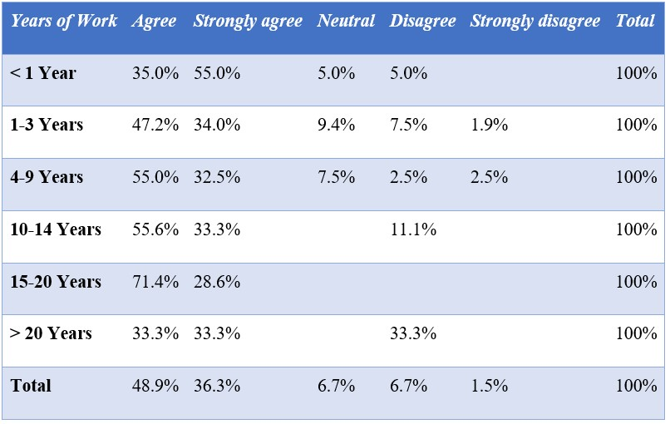
Table 4.4.5.2 Years working for current employer * Q9 Cross-tabulation
Respondents working for under a year, agree with a total of 90% with the above statement. Respondents working between 1-3 years, either agree or strongly agree (81,2%), while 9,4% disagree or strongly disagree. Respondents working for 4-9 years agree or strongly agree with a total of 87,5%, while 5% disagree or strongly disagree. 89,9% of respondents working for 1014 years agree or strongly agree, while the remaining 11,1% disagree. Respondents working for 15-20 years agree or strongly agree to 100%. Respondents working for above 20 years split their answers between strongly agree (33,3%), agree (33,3%) and disagree (33,3%).
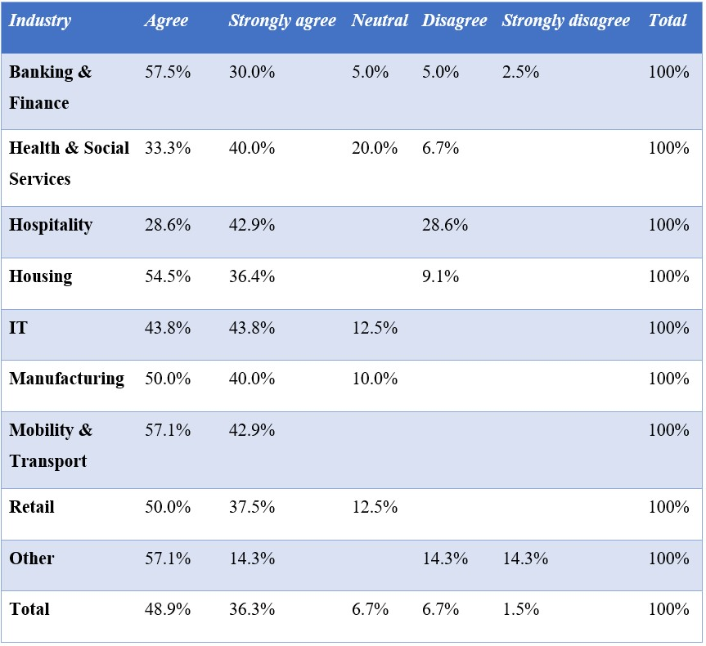
Table 4.4.5.3 - Industry * Q9 Cross-tabulation
The respondents giving the most positive answers thereby stating that their supervisor is available for questions, had the backgrounds Mobility and Transport (100%), Housing (90,9%), Manufacturing (90%), Banking and Finance (89,9%), IT (87,6%) and Retail (87,5%).
The respondents giving the most negative responses being either disagree or strongly disagree came from the backgrounds Hospitality (28,6%) and Other (28,6%). All named industries do have more positive answers than negative ones. The total of respondents disagreeing or strongly disagreeing is 8,2%.

.4.6 Participation
I am given the space to express myself
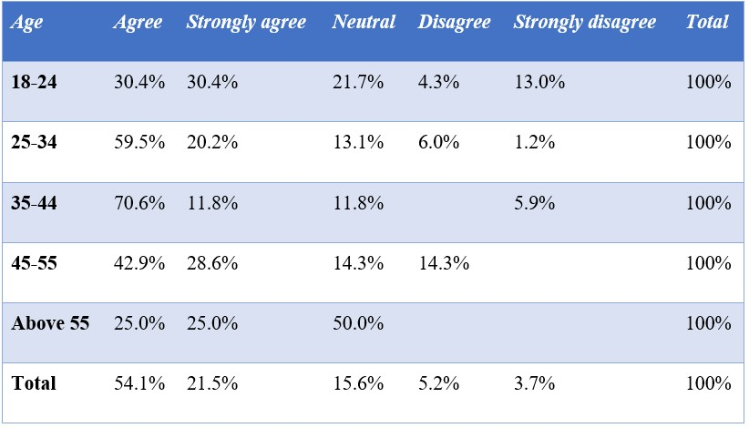
Table 4.4.6.1 - Age * Q11 Cross-tabulation
60,8% of the 18-24-year-olds believe they are given the space to express themselves, by either agreeing or strongly agreeing to the above statement. 17,3% disagree or strongly disagree. 79,7% of the 25-34-year-olds agree or strongly agree, while 7,2% disagree. 82,4% of 35-44-year-olds agree or strongly agree, while 5,9% strongly disagree. 71,5% of the age group between 45 and 55, agree or strongly agree, while 14,3% remain neutral and 14,3% disagree.
50% of the above 55-year-old respondents agree, while 50% remain neutral.
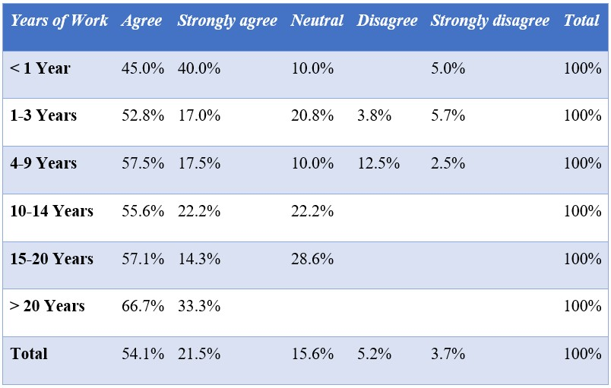
Table 4.4.6.2 Years working for current employer * Q11 Cross-tabulation
Respondents working for under a year agree to 85%. Respondents working for 1-3 years agree or strongly agree with a total of 69,8%. 20,8% remain neutral and 9,5% disagree or strongly disagree. 75% of respondents working for 4-9 years agree or strongly agree while 15% disagree or strongly disagree. 77,8% of respondents working for 10-14 years agree or strongly agree, while none of them disagrees with the above statement. Similar results exist for respondents working 15-20 years. Respondents working for over 20 years agree or strongly agree to 100%.
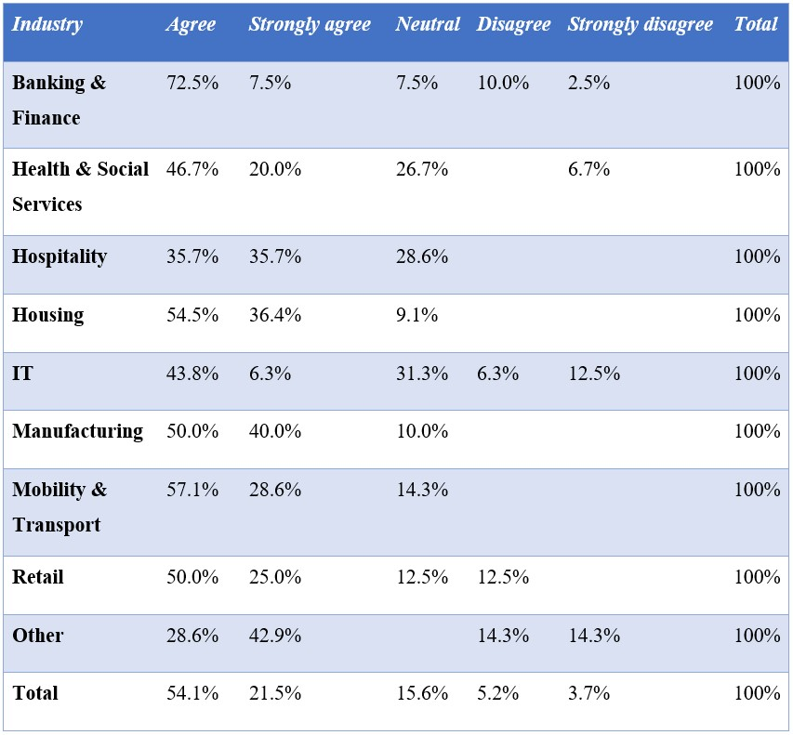
Table 4.4.6.3 - Industry * Q11 Cross-tabulation
The respondents which mainly agreed or strongly agreed with the above statement and therefore state that they are given the opportunity to express themselves had the backgrounds Housing (90,9%), Manufacturing (90%), Mobility and Transport (85,7%), Banking and Finance (80%) and Retail (75%). The respondents to disagree or strongly disagree were mainly found in the industries categorized as Other (28,6%) and IT (18,8%).

4.4.7 Personal Development
My company has options for training & personal development
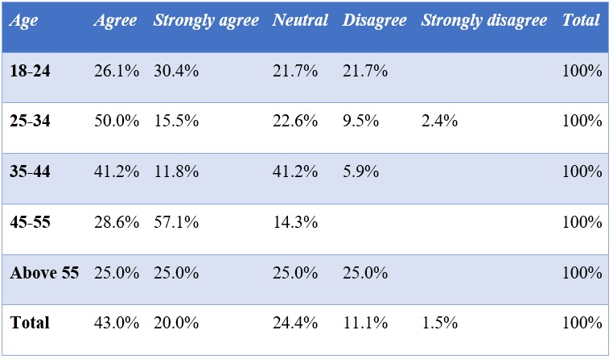
Table 4.4.7.1 - Age * Q16 Cross-tabulation
56,5% of respondents within the age group 18-24 agree or strongly agree with the above statement, while 21,7% disagree. 65,5% of 25-34-year-olds agree or strongly agree, while 11,9% strongly disagree or disagree. 53% of the age group 35-44 years agree or strongly agree with the above statement. 41,2% remain neutral, while 5,9% disagree. 85,7% of 45-54-year-old respondents agree or strongly agree, while 14,3% remain neutral. 50% of respondents above 55 agree or strongly agree. 25% remain neutral and 25% disagree.
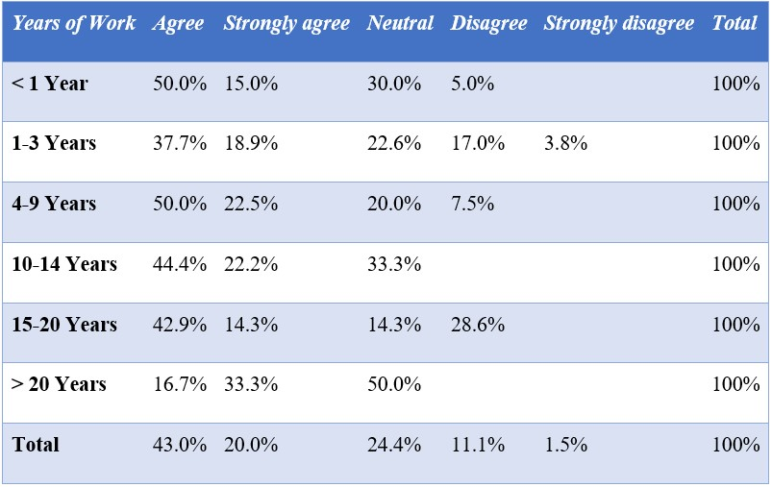
Table 4.4.7.2 - Years working for current employer * Q16 Cross-tabulation
Respondents working for their current employer for under a year, agree or strongly agree with a total of 65%, while 30% remain neutral. Respondents working for 1-3 years, agree or strongly agree with a total of 56,6%. 22,6% remain neutral and 20,8% disagree or strongly disagree. Respondents working for 4-9 years agree or strongly agree with a total of 72,5%. The group working for 10-14 years agrees or strongly agrees to 66,6%, while 33,3% remain neutral. Respondents working between 15 and 20 years agree or strongly agree with a total of 57,2%, while 28,6% disagree. Respondents working for their current employer for over 20 years either remain neutral (50%), agree (16,7%) or strongly agree (33,3%).
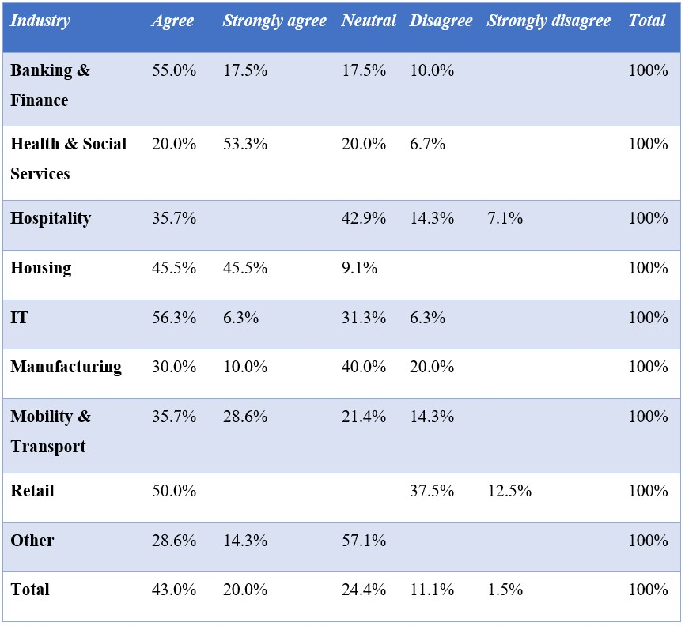
Table 4.4.7.3 - Industry * Q16 Cross-tabulation
The respondents which agreed or strongly agreed the most frequently, therefore stating that their employer offers options for personal development, have the backgrounds Housing (91%), Health and Social Services (73,3%) and Banking and Finance (72,5%). The respondents giving the most negative responses have the backgrounds Retail (50%), Hospitality (20,4%) and Manufacturing (20%). Within Manufacturing and Hospitality, 40% and 35,7% also agreed or strongly agreed with the above statement. Within Retail, the answers are divided between agree (50%) and disagree or strongly disagree (50%).

4.4.8 Employee retention
I plan a long-term career in this company
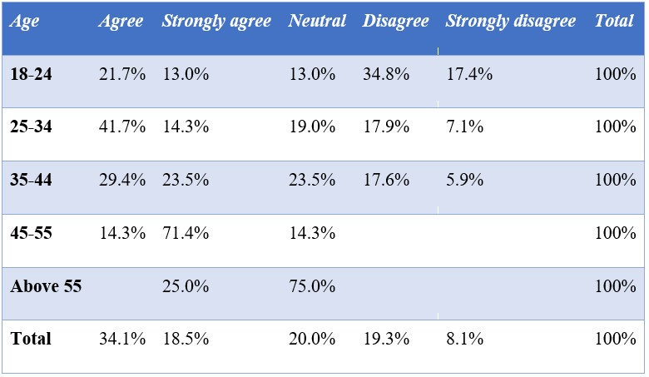
Table 4.4.8.1 - Age * Q17 Cross-tabulation
Respondents between 18-24 years, agree or strongly agree with a total of 34,7%, while 52,2% disagree or strongly disagree. Respondents between 25-34 years, 56% stated agree or strongly agree, while 25% disagree or strongly disagree. 52,9% of the 35-44-year-old respondents agree or strongly agree with the above statement. 23,5 % remain neutral, while 23,5% disagree or strongly disagree. 14,3% of the 45-54-year-olds agree and 71,4% state strongly agree, while none disagrees. 75% of the above 55-year-olds remain neutral, while 25% strongly agree.
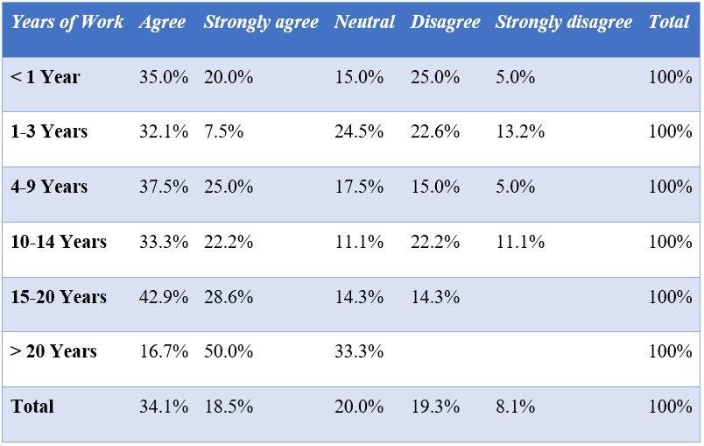
Table 4.4.8.2 - Years working for current employer * Q17 Cross-tabulation
Respondents working for under a year, agree or strongly agree with the above statement with a total of 55%, while 30% disagree or strongly disagree. Of the respondents working 1-3 years, 39,6% agree or strongly agree while 35,5% disagree or strongly disagree. 62,5% of the 4-9years work-experience group, agrees or strongly agrees, while 20% disagree or strongly disagree. The respondents working 10-14 years agree or strongly agree to 55,5%, with 33,3% disagreeing or strongly disagreeing. Respondents working 15-20 years, agree or strongly agree with a total of 71,5%, while 14,3% disagree. Respondents working for their current employer above 20 years remain neutral (33%), agree (16,7%) or strongly agree (50%).
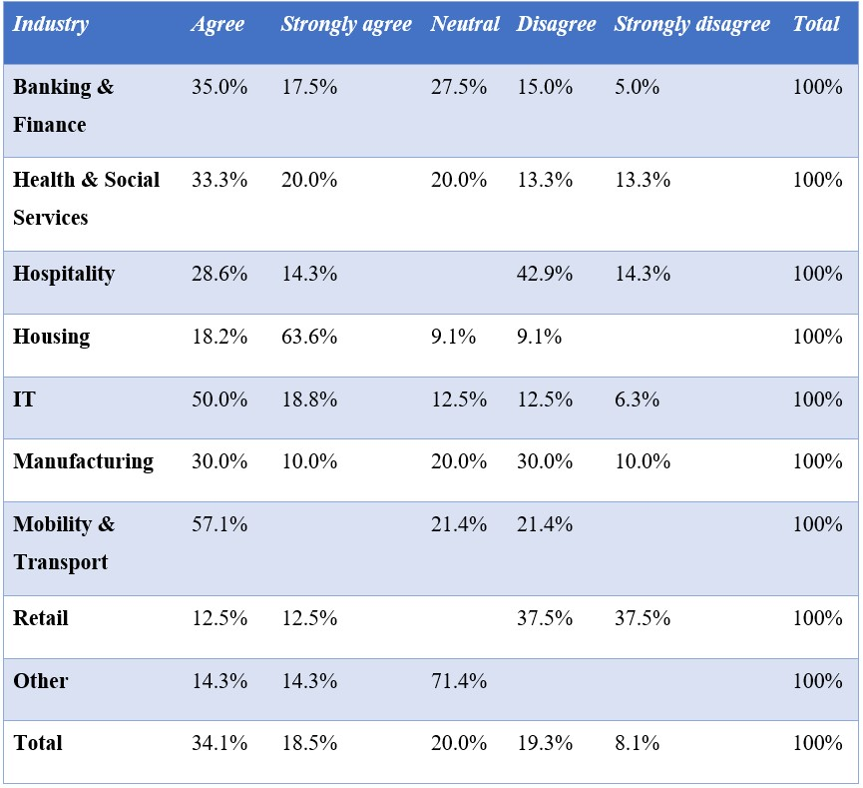
Table 4.4.8.3 - Industry * Q17 Cross-tabulation
The industries where respondents stated the most positive results, meaning they are willing to plan a long term-career, are within Housing (81,8%) and IT (68,8%). Within Manufacturing as 40% of respondents agree or strongly agree, while 40% disagree or strongly disagree, with 20% remaining neutral. The industries where respondents stated the most negative results, being either disagree or strongly disagree are Retail (75%) and Hospitality (57,2%).

4.4.9 Overall level of satisfaction
I would recommend this company as an employer
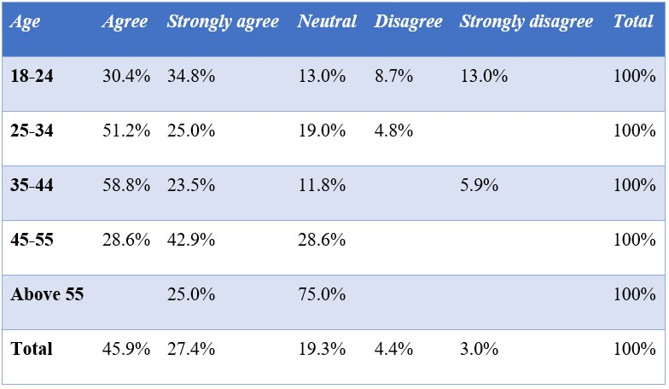
Table 4.4.9.1 - Age * Q18 Cross-tabulation
65,2% of 18-24-year-olds state that they would recommend their current employer as they either agree or strongly agree, while 21,4% disagree or strongly disagree. 76,2% of 24-34-year-olds agree or strongly agree, while 4,8% disagree. 82,3% of 35-44-year-olds agree or strongly agree with the above statement. 5,9% strongly disagree. Respondents between 45-54 years mainly agree or strongly agree (71,5%), while 28,6% remain neutral. Of the above 55-year-olds, 75% remain neutral, while 25% strongly agree.
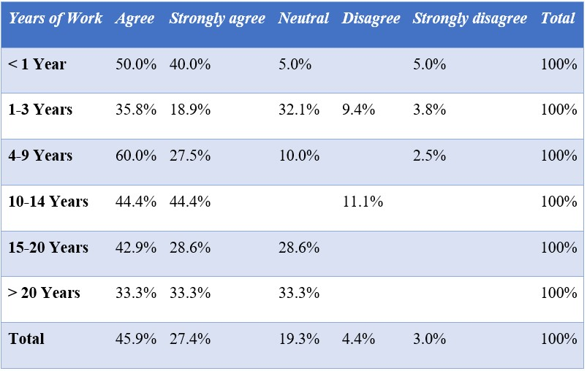
Table 4.4.9.2 - Years working for current employer * Q18 Cross-tabulation
Respondents working for under a year, agree or strongly agree to 90%, while 5% strongly disagree. Respondents working for 1-3 years strongly agree or agree (54,7%), while 32,1% remain neutral and 13,2% strongly disagree or disagree. 87,5% of respondents working between
4 and 9 years, agree or strongly agree, while 2,5% strongly disagree. Respondents working 1014 years agree or strongly agree with a total of 88,8% with the remaining 11,1% disagreeing. Respondents working for 15-20 years either agree or strongly agree (71,5%) or remain neutral (28,6%). The respondents working for their current employer for over 20 years evenly split their answers between strongly agree (33,3%), agree (33,3%), and neutral (33,3%).
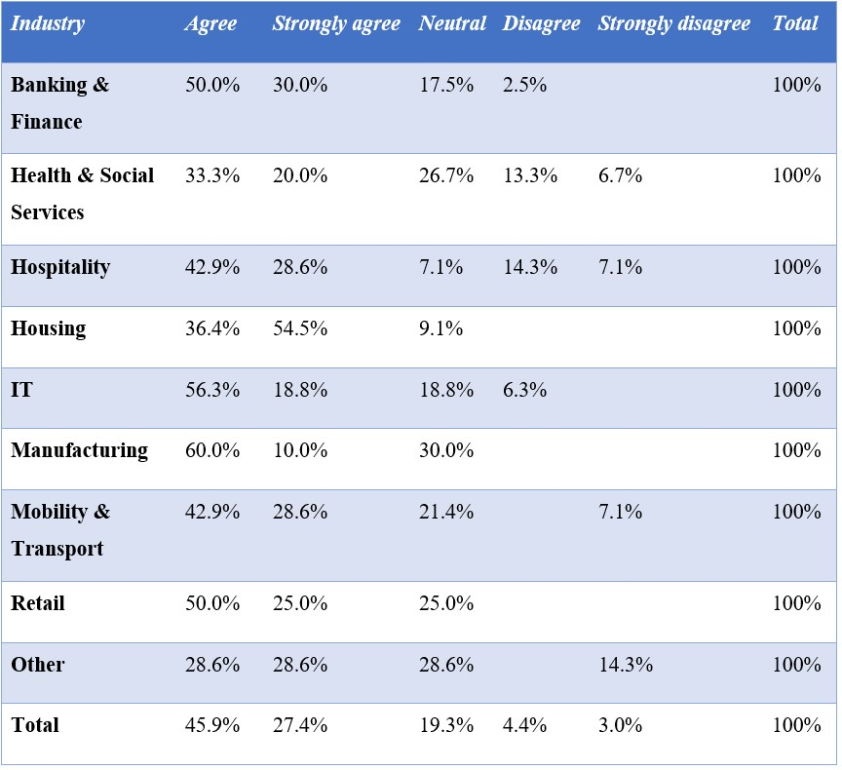
Table 4.4.9.3 - Industry * Q18 Cross-tabulation
The respondents giving the most positive answers thereby stating either strongly agree or agree came from the backgrounds Housing (90,9), Banking and Finance (80%), IT (75,1%), Retail (75%), Hospitality (71,5%) and Manufacturing (70%).
The respondents giving the most negative answers meaning either strongly disagree or disagree came from the backgrounds Hospitality (21,4%) and Health and Social Sciences (20%). Both industries received nonetheless more positive than negative answers. The negative answers of all respondents within all categories came to a total of 7,4%.

CHAPTER 5 - DISCUSSION OF THE STUDY’S CONTRIBUTION
This chapter deals with the analysis of the most crucial results found within the survey. The following observations will be compared and connected to the chosen theories.

5.1 CSR
Earlier presented research stated, that CSR leads to enormous human resource benefits, especially in form of increased employee retention (Vinerean et al., 2013b; Bonini et al., 2009 as cited in Lee & Chen, 2018). The authors’ findings suggest a less straightforward relationship.
Even with questions about employee satisfaction being answered in an overall positive way, employee retention intention is not as high as the level of satisfaction might suggest. Except for the age group between 44-54 years, which agrees to 71,4% that they plan a long-term career at their current employer, other age groups agree to approximately 50%. The youngest generation between 18-24 years only agrees to 34,7% and even disagrees with 52,2%. CSR needs, therefore, to be used especially for younger employees. The oldest generation (above 55) stayed mainly neutral (75%), which can also be due to them already having worked all their life, which is why they do not plan a long-term career any longer. Respondents working for their current employer for under a year agree at least to 55%, while workers working in between 1-3 years only agree to 39,6%. While employees having a fresh start at their employers are being more willing to plan a long-term career, workers are having less motivation to do that after the first year. CSR needs, therefore, to be further used to motivate employees working for over a year to stay at their current employer. Employees working longer periods state a level of agreement between 55,5% and 71,5%. CSR can also here help further to improve that level. Respondents with the highest employee retention intention are having the backgrounds Housing and IT. The stable job market within the housing industry and the new job possibilities regarding IT may be a reason for that. Retail and Hospitality face the lowest agreement, which might be due to partly physical work and lower salaries. CSR strategies cannot change the main type of a physically and mentally tiring job, which might be a reason for this outcome.

5.2 HRM
HRM deals specifically with the satisfaction and commitment of employees (Vinerean et al.,
2013a; Bučiūnienė & Kazlauskaitė, 2012). According to the findings, the overall level of employee satisfaction seems to be high, as workers are willing to recommend their employer.
Younger generations seem to be harder to satisfy, as they generally show a lower level of agreement, which matches previous studies (Moore et al., 2014). Here, companies should focus their HRM on younger employees. Paradoxically, are employees working for their current employer for under a year willing to recommend their employer to 90%, while workers working between 1-3 years only state 54,7%, which is the lowest level of agreement. The first excitement and satisfaction that comes with a new job, seems therefore to have disappeared after the first year. Employees may have experienced their first problems after their first year at work and may still be too inexperienced to deal with these problems, opposite to older employees and employees working longer periods. Employees working these longer periods (3 to above 20 years) state a minimum agreement of around 70%. Companies should therefore not only focus their HRM on new employees, but mainly on the ones which may not be categorized as new, but still inexperienced. Room for improvement can further be seen regarding long-term workers. Respondents being the most satisfied with their employer have the backgrounds Housing as well as Banking & Finance. These two industries may have more experienced HRM, than the industries of Hospitality and Health & Social Services, which state the lowest level of agreement.

5.3 Employees’ Needs
Employees' needs were identified by using Maslow’s pyramid of needs. These needs were later translated into possible CSR and HRM policies within the working environment
(Ramlall, 2004 and Tanner, 2020). Employees’ needs are, according to the survey conducted, mainly satisfied as the overall answers to the questions were positive.
Physiological needs within the work environment, which can be satisfied by providing necessary facilities and a stimulating design of workspaces, are perceived as satisfied by the majority of all demographic categories. An interesting observation is that the level of satisfaction decreases the older the respondents are. The youngest age group, between 18-24 years, which agreed to the highest extend (82,6%), may be less picky regarding their work environment than the respondents above 55, which only agree to 50%. When it comes to dividing the respondents according to the years working for their employer, respondents working between 1-3 years are the most unsatisfied, while respondents under a year and respondents working in between 15 to above 20 years are the happiest. Respondents working for under a year may have lower expectations as they are just starting at an employer, while the employees working in between 1-3 years are harder to satisfy. Employees working for longer periods are more satisfied, as they may have moved to bigger offices or have actively shaped their workspaces over time. The industries which were the happiest with their workenvironment were Housing and IT. These industries seem therefore to offer the most satisfying offices and work equipment. The most negative responses were found within Mobility & Transport and Hospitality. The reasons might be the small workspaces given to workers and the lack of break rooms that can occur within these industries.
Safety needs were analysed in the form of the given Salary. Here, the level of Satisfaction is generally lower for the younger generations. As the respondents get older (starting at 35 years), the level of satisfaction increases, until it reaches 100% for respondents above 55. Respondents working for their current employer for under a year, agree to a higher extent with their given salary than respondents working for 1-3 years. After 3 years of work experience, the level of satisfaction increases again, until reaching 100% when working for above 20 years for the current employer. At first, workers may be glad to accept whichever salary they receive, until they stay longer and expect more. As workers are more satisfied the older, they are and the longer they stay, companies seem to have handled this problem, excluding the workers working between 1-3 years. Housing and Health & Social Services receive the highest level of satisfaction regarding their salary, opposite to Manufacturing and Hospitality, which receive the lowest level of satisfaction. Lower wages can generally be found within these industries, which leaves room for improvement.
Belongingness is another important need that can be translated into teamwork within the work environment. In this case, the younger generations of up to 34 years, rather stated that their company embraces teamwork, while the older generations were agreeing to a lesser extent. The amount of teamwork seems hereby to be decreasing the older the respondents get, which could be due to older workers being more experienced and needing less confirmation and help from others. Respondents working for their current employer for under a year, state the highest level of agreement, which could be due to the fact that they may still need help from other workers when just starting at an employer, which thereby automatically leads to more teamwork. Industries with the highest level of teamwork were Banking & Finance and Retail, while the industries disagreeing the most to the statement are respondents coming from Mobility & Transports as well as Hospitality. Cooperation and teamwork may be less needed within certain industries where tasks are clear and simple, but the lack of teamwork may nonetheless influence the satisfaction of workers.
The need for Self Esteem, which can be satisfied through the allowance of participation led to diverse answers, without following a clear pattern. The option to express oneself is apparently given the most frequently to 35-44-year-olds, which could be due to their age and experience in the job. The youngest generation (18-24-year-olds) seems to have fewer options to express themselves, which was expected as they are less experienced and still have a lot to learn within their job. Paradoxically, the level of agreement decreases for respondents being above 44 years, which might also be due to the respondents’ industry and the employer they are working for. Respondents working for their current employer for under a year seem to have the highest level of options to express themselves. Employees in all other categories (working between 1 to 20 years), state a lower level of agreement. This could be due to the fact that new workers are allowed to ask a lot of questions when beginning a new job. Employees working for above 20 years agree to 100%, which could be due to the fact that they had time to work their way up and now have a lot of influence within a specific company. Allowance of participation should therefore not only be given to new workers and highly experienced ones, but rather to employees in all categories. The industries stating the highest level of participation among workers are Housing and Manufacturing, while the industries with the lowest level of participation are Other and IT. Here, employers need to encourage workers to express themselves to a higher extent, in order to fulfil Self-Esteem needs of workers and encourage employee satisfaction.
The need for Self-Actualization was translated into Training and Personal Development. 44-54year-olds state that the option is given the most frequently, while all other age groups agree to a much lesser extent. Employees working between 4-9 years state the highest level of agreement (72,5%), while no other group sticks out. The authors expected that rather younger generations would state that the option is given the most frequently, but the answers state otherwise. Companies may want workers to gain experience first, before offering Training. This leads older workers to be more motivated to stay within a certain company, which seems beneficial as older workers have more knowledge about an organization. The loss of resources is higher in the case of a more experienced employee leaving the company (Boushey & Glynn, 2012). The industries which seem to receive training the most frequently are Housing, Banking & Finance, and Health & Social Services, while Retail and Hospitality disagree to the highest extent. Even though Self-Actualization is on the top of the pyramid and therefore given less importance than the other four factors, training is a crucial tool to retain employees.

5.4 Motivation Factors and Hygiene Factors
As mentioned earlier in the study, Herzberg’s theory (1966) highlights the importance of Hygiene Factors and Motivators. The hygiene factors hereby lead to short term satisfaction, while the motivating factors lead to long term-satisfaction (Herzberg, 1966, as cited in Alshmemri et al., 2017).
The motivation factors advancement and responsibility, which were both translated into the feeling of contributing to something meaningful, give the employee a feeling of status and satisfaction from a given responsibility (Herzberg, 1966, as cited in Alshmemri et al., 2017). Most respondents in the age categories from 18-44, feel like they are contributing to something meaningful. Individuals aged 45 and above agree to a lesser extent. Disagreement further is the highest for workers with above 20 years of work experience. The authors believe that the reason behind this decrease in satisfaction is the level of routine when performing a job, so an employee no longer feels that he or she is making a difference. Their status or position in the company may also have been settled for a longer period, so older employees do not feel that there is any more room for advancement. Younger respondents may also feel more optimistic than older respondents in general, about contributing to something meaningful. A young employee may also rather feel proud about their new job, status and responsibility given, than an experienced employee who had their job and status for a longer period. There further are some branches that are strengthening the feeling of contribution more than others, such as IT and Mobility & Transport.
The motivation factor, growth, shows that employees of the youngest and oldest age groups are rather not offered the chance of receiving training and development, compared to middle-aged groups. To achieve long-term satisfaction, options for growth need to be given to all age groups to at least some extent. The only industries that do not feel dissatisfied with their training and development options, are found within the Housing and ‘Other’ industry. Although the group ‘Other’ does not show dissatisfaction, many of the employees feel neutral.
The level of satisfaction regarding the three presented motivation factors, differs across demographic groups, and needs to be further considered by employers in order to ensure longterm satisfaction. Attention should be paid especially to the oldest and youngest workers.
The results, regarding the different hygiene factors show a generally high level of acceptance and satisfaction.
The hygiene factor work-conditions, which was translated into the general working environment in the form of facilities offered, was mainly perceived as positive. Here, a total of 19,4% of all respondents disagrees about having a good working environment. Nonetheless did especially the younger generations seem overall satisfied. One can argue that workers may be willing to accept their workspaces as they perceive it as less important. Humans are further having the ability to adapt over time, which also reduces the level of dissatisfaction.
It is noticeable that the hygiene factor salary seems more crucial for employees, as all respondents under the age of 55, stated a certain level of dissatisfaction. Here, the level of agreement was 100% for respondents above 55. Similarities can be seen looking at respondents that have been working for their current employer for a longer period. No respondent having worked for over a ten-year period, feels dissatisfied regarding their salary. This leaves the authors to assume that either the salary increases, or money becomes less important when getting older. The only entirely satisfied employees are within Housing, which could mean that the branch generally offers good salaries. More physically demanding jobs generally show a higher level of dissatisfaction regarding their salary, which is understandable considering the lower level of skills and experience needed for doing a job, which mostly results in lower salaries.
The hygiene factor, relationships, which was translated into teamwork, shows the most negative results in the study. All age groups, except the one above 55 and all groups divided by years of work, state a certain lack of teamwork. The only industry that shows total satisfaction is the retail industry. Teamwork forms a weakness for all other industries within this study. It not only affects productivity but also the feeling of connection to an organization. Creating negative feelings, such as lack of affiliation to a workplace, is a barrier to the well-being of employees.
Supervision is the last hygiene factor studied in the survey. The factor was translated into the supervisor being available for questions. Agreement regarding the employee’s supervision was received from all age groups, while a smaller rate of disagreement was received, especially from respondents above 45. Disagreement can also be found within the answers of respondents with over 20 years of experience. In order to not demotivate more experienced and older employees, supervision should be decreased over time, while assuming that experience and knowledge gained over time are enough to perform a job. A possible answer regarding the disagreement of older respondents could be that some of the more experienced and older workers may have become supervisors themselves and therefore do not have a direct supervisor to ask questions any longer. All industries included in this study, except for Mobility & Transport are facing employee dissatisfaction regarding their supervision, which is a weakness that needs to be considered.
Apart from the relationship factor, a high level of agreement regarding the hygiene factors can be recognized, which should lead to short-term satisfaction, according to Herzberg (1996) as cited in Alshmemri et al. (2017).

5.5 Concluding Discussion
The authors started this study by assuming that internal CSR directed at employees, has the power to influence employee retention. The perception of CSR seemed hereby a crucial factor to consider (Kuvaas, 2008). Needs, Motivation and Hygiene Factors were used to explain employees’ preferences and the resulting different perceptions in-depth. These factors were later found to be crucial influences, to which CSR policies need to be adapted to, in order to be successful.
CSR policies directed at employees, together with HRM do affect employee satisfaction when needs and motivation & hygiene factors are considered. But even if a high level of satisfaction is achieved, employee retention intention is not guaranteed. Employees can state that they are satisfied with their current work environment, and still not have a retention intention, due to other reasons, which were not covered in this study. Nonetheless, can it also be observed that industries, with lower employee satisfaction, have a lower employee retention intention. Therefore, the authors’ contribution of this thesis is the conclusion that CSR directed at employees does have a direct impact on employee satisfaction but not on employee retention. Not all satisfaction achieved by CSR and HRM leads to retention intention.

5.6 Future Research
Future research to be conducted could be the focus on two specific industries, for example, Banking & Finance and Hospitality, to gain a clearer picture of a specific industry. Certain industries, such as Hospitality do not have a high employee retention intention. A study where different employers offer the same CSR policies within different industries can be an interesting and unique approach to analyse the effects of CSR.

References
- Abbott, J. (2003). Does employee satisfaction matter? A study to determine whether low employee morale affects customer satisfaction and profits in the business-tobusiness sector. Journal of Communication management, 7(4): 333-339.
- Adair, J. E. (2006). Leadership and motivation: The fifty-fifty rule and the eight key principles of motivating others. Great Britain: Kogan Page Publishers.
- Akorede, S. (2018, July 30). Three Things to Learn from Google’s Workplace Culture.
Retrieved from https://www.entrepreneur.com/article/317582.
- Aminudin, N. (2013). Corporate social responsibility and employee retention of ‘Green’ Hotels. Procedia-Social and Behavioral Sciences, 105: 763-771.
- Alshmemri, M., Shahwan-Akl, L., & Maude, P. (2017). Herzberg’s Two-Factor Theory. Life Science Journal, 14(5): 12-16.
- Barakat, S.R., Isabelle, G., Boaventura, J.M.G. & Mazzon, J.A. (2016). The influence of Corporate Social Responsibility on employee satisfaction. Management Decision, 54(9): 2325-2339.
- Beddewela, E., & Fairbrass, E. (2015). Seeking Legitimacy through CSR: Institutional Pressures and Corporate Responses of Multinationals in Sri Lanka. Journal of Business Ethics, 136: 503-522.
- Bernstein, D. A., & Nash, P. W. (2008). Essentials of psychology (4th ed.). Boston, United States: Cengage Learning.
- Boushey, H., & Glynn, S. J. (2012) There Are Significant Business Costs to Replacing Employees. Center for American Progress.
- Branham, L. (2005). The 7 Hidden Reasons Employees Leave. New York, United States: AMACOM, a division of American Management Association.
- Bryman, A., & Bell, E. (2015). Business Research Methods (3rd ed.). Great Clarendon Street, United Kingdom: Oxford University Press.
- Bryman, A., & Bell, E. (2015). Business Research Methods (4th ed.). Great Clarendon Street, United Kingdom: Oxford University Press.
- Bučiūnienė, I., & Kazlauskaitė, R. (2012). The linkage between HRM, CSR and performance outcomes. Baltic Journal of Management, 7(1): 5-24.
- Chuang, C., & Liao, H. (2010). Strategic Human Resource Management in Service Context: Taking care of employees and customers. Personnel Psychology, 63(1): 153196.

Fortune. (2017). The 100 Best Companies To Work For. Retrieved from https://fortune.com/best-companies/2017/google/.
- Gawel, J.E. (1996). Herzberg's Theory of Motivation and Maslow's Hierarchy of Needs. Practical Assessment, Research, and Evaluation, 5(11).
- Gond, J.P., El Akremi, A., Swaen, V. & Babu, N. (2017). The psychological microfoundations of corporate social responsibility: A person‐centric systematic review. Journal of Organizational Behavior, 38(2): 225-246.
- Gore & Associates, Inc. (2020). Our Culture. Retrieved from https://www.gore.com/about/culture.
- Graham, J., Harvey, C., Popadak, J. & Rajgopal, S. (2016). Corporate Culture:
Evidence from the Field. NBER, (23255).
- Hong, L.C., Hamid, N.I.N.A., & Salleh, N.M. (2013). A Study on the Factors Affecting Job Satisfaction amongst Employees of a Factory in Seremban, Malaysia.
Business Management Dynamics, 3(1): 26-40.
- Inabinett, J. M., & Ballaro, J. M. (2014). Developing an organization by predicting employee retention by matching corporate culture with employee’s values: A correlation study. Organization Development Journal, 32(1): 55–74.
- Judge, T. A., & Church, A. H. (2000). Job satisfaction: Research and practice. In C. L. Cooper & E. A. Locke (Eds.), Industrial and organizational psychology: Linking theory with practice, 166-198.
- Kapur, R. (2018). Factors Influencing Job Satisfaction. University of New Delhi.
- Kaur, A. (2013). Maslow’s Need Hierarchy Theory: Applications and Criticisms.
Global Journal of Management and Business Studies, Vol. 3, Number 10: 1061-1064.
- Kumari, G., Joshi, G. & Pandey, K.M. (2014). Analysis of Factors Affecting Job
Satisfaction of the Employees in Public and Private Sector. IJTEMT, 3(1): 11-19.
- Kuvaas, B. (2008). An exploration of how the employee-organization relationship affects the linkage between perception of developmental human resource practices and employee outcomes. Journal of Management Studies, 45(1): 1-25.
- Lee L., & Chen, L. (2018). Boosting employee retention through CSR: A configurational analysis. Corporate social environment management, 25(5): 948-960.
- MANDHANYA, Y. (2015), A STUDY OF IMPACT OF WORKING
ENVIRONMENT ON RETENTION OF EMPLOYEES (With special reference to Automobile sector). Global Management Review, 9(4): 116-128.
Miles, M. B., & Huberman, A. M. (1994). Qualitative data analysis: An expanded sourcebook (2nd ed.). Thousand Oaks, CA: Sage Publications, Inc.
- Moore, S., Grunberg, L. & Krause, A. (2014). Generational Differences in Workplace Expectations: A comparison of Production and Professional Workers. Current Psychology, 34(2): 346-362.
- Nazia, S. & Begum, B. (2013). EMPLOYEE RETENTION PRACTICES IN INDIAN CORPORATE – A STUDY OF SELECT MNCs. International Journal of Engineering and Management Sciences, 4(3): 361-368.
- Patel, S. (2015, August 6). 10 Examples of Companies with Fantastic Cultures.
Retrieved from https://www.entrepreneur.com/article/249174.
- Peng L.M. (2014). Internal Corporate Social Responsibility: An Overview, AENSI Journals, 8(16): 18-29.
- Ramlall, S. (2004). A Review of Employee Motivation Theories and their Implications for Employee Retention within Organizations. Journal of American academy of business, 5(1/2): 52
- Rondeau, K.V. & Wagar, T.H. (2001). Impact of Human Resource Management Practices on Nursing Home Performance. Health Services Management Research, 14(3): 192-202.
- Rödig, P. & Zalud, J. (2019) Blockchain – facilitator of trust or substitute (Master Thesis, Jönköping University, Jönköping, Sweden).
- Saunders M., Lewis P., & Thornhill A., (2009). Research Methods for Business Students (5th ed.). Edinburgh Gate, England: Pearson Education Limited.
- Saeidi, S.P., Sofian, S., Saeidi, P., Saeidi, S.P. & Saaeidi, S.A. (2015). How does corporate social responsibility contribute to firm financial performance? The mediating role of competitive advantage, reputation, and customer satisfaction.
Journal of Business Research, 68(2): 341-350.
- Squarespace. (2020). Helping Creative Ideas Succeed. Retrieved from:
https://www.squarespace.com/about/company.
- Story, J., Neves, P. (2015) When corporate social responsibility (CSR) increases performance: exploring the role of intrinsic and extrinsic CSR attribution. Business Ethics: A European Review, 24(2): 111-124.
- Vinerean, S., Cetina, I. & Dumitrescu, L. (2013a). Modelling Employee Satisfaction in Relation to CSR Practices and Attraction and Retention of Top Talent. Expert Journal of Business and Management, 1(1): 4-14.
Vinerean, S., Cetina, I., Dumitrescu, L. & Tichindelean, M. (2013b). Modelling employee engagement in relation to CSR practices and employee satisfaction. Revista Economica, 65(1): 21-37.
- Vlachos, P., Panagopolous, N. & Rapp, A. (2013). Feeling Good by doing good: Employee CSR-induced Attributions, Job Satisfaction, and the Role of Charismatic Leadership. Journal of Business Ethics, 118(3): 577-588.
- Wright, P., Gardner, T., & Moynihan, L. (2003). The impact of HR practices on the performance of business units. Human Resource Management Journal, 13(3): 21–36. • Zhu, Q., Yin, H., Liu, J. & Lai, K. (2014). How is employee perception of
Organizational efforts in Corporate Social Responsibility related to their satisfaction and loyalty towards developing harmonious society in Chinese enterprises? Corporate Social Responsibility and Environmental Management, Vol.21(1): 28-40.

APPENDIX 1 – Survey Questionnaire
 |  | 1 | 2 | 3 | 4 | 5 | Source
v | I am satisfied with the current working environment (break room, office design, coffee machine etc.) |  |  |  |  |  | Zhu et al., 2014
v | My company offers a fair salary |  |  |  |  |  | Lee & Chen, 2017
v | I feel like having a work-life balance (vacation, allowance for days off due to personal issues etc.) |  |  |  |  |  | Turban & Greening, 1997 as cited in Barakat et al., 2016
v | I feel like I am receiving the support I need from my company (mental and physical health care, consulting etc.) |  |  |  |  |  | Zhu et al., 2014
v | My company offers meetings for an exchange of information and complaints |  |  |  |  |  | Lee & Chen, 2017
v | My company embraces teamwork for example by organizing different (entertaining) activities / projects |  |  |  |  |  | Lee & Chen, 2017
v | I feel happy to come to work |  |  |  |  |  | Lee & Chen, 2017
v | I feel that I am contributing to something meaningful at work |  |  |  |  |  | Pavlos et al., 2013
v | My supervisor is available for questions |  |  |  |  |  | Lee & Chen, 2017
v | My company welcomes new ideas |  |  |  |  |  | Pavlos et al., 2013
v | I am given the space to express myself |  |  |  |  |  | Turban & Greening, 1997 as cited in Barakat et al., 2016
v | I am given the support to pursue my ambitions |  |  |  |  |  | Harter et al., 2002 as cited in Barakat et al.,  2016
v | My supervisor provides clear instructions |  |  |  |  |  | Pavlos et al., 2013
v | I feel that I can handle my current workload |  |  |  |  |  | Zhu et al., 2014
v | I feel that I can use my skills |  |  |  |  |  | Lee & Chen, 2017
v | My company has options for training & personal development |  |  |  |  |  | Vinerean et al., 2013
v | I plan a long-term career in this company |  |  |  |  |  | Lee & Chen, 2017
v | I would recommend this company as an employer |  |  |  |  |  | Lee & Chen, 2017

APPENDIX 2 - Presentation of Descriptive Statistics
Q1 - I am satisfied with the current working environment (break room, office design, coffee machine, etc.)
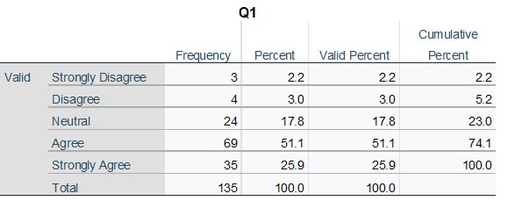
Q2- My company offers a fair salary
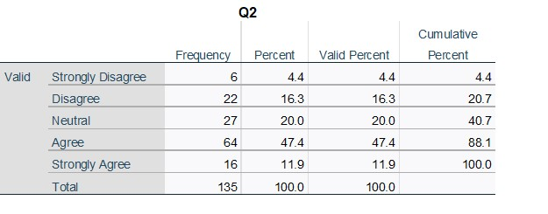
Q3 - I feel like having a work-life balance (vacation, allowance for days off due to personal issues, etc.)
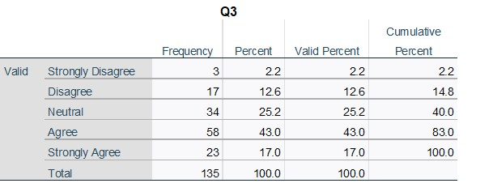
Q4 - I feel like I am receiving the support I need from my company (mental and physical health care, consulting, etc.)
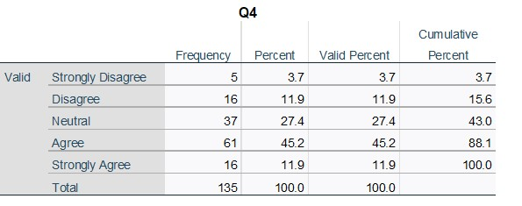
Q5- My company offers meetings for an exchange of information and complaints
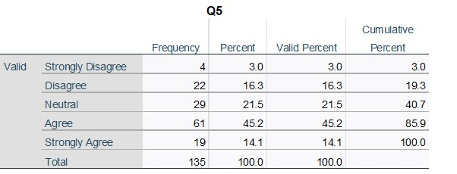

Q6- My company embraces teamwork for example by organizing different activities/projects
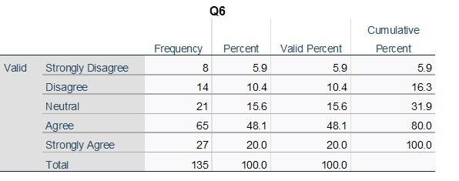

Q7- I feel happy to come to work
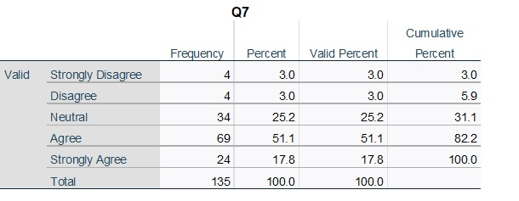
Q8- I feel that I am contributing to something meaningful at work
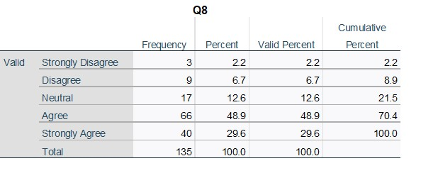
Q9- My supervisor is available for questions
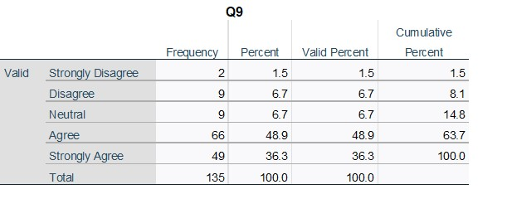

Q10- My company always welcomes new ideas
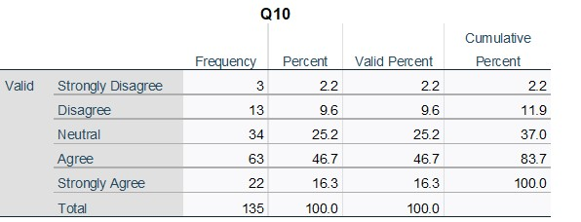

Q11- I am given the opportunity to express myself
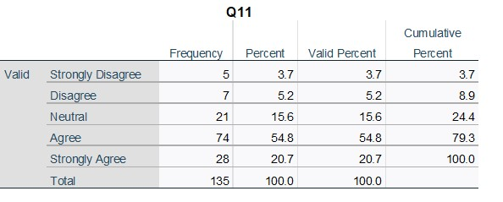
Q12-I am given the support to pursue my ambitions

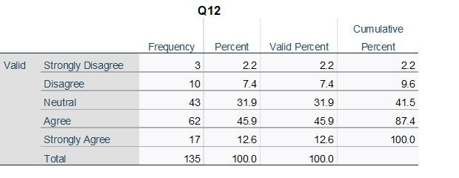

Q13- My supervisor provides clear instructions
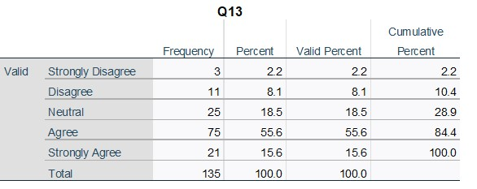
Q14- I feel like I can handle my current workload
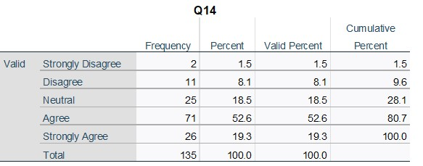
Q15- I feel like I can use my skills

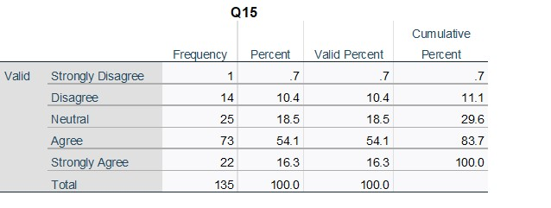

Q16- My company provides options for training & personal development
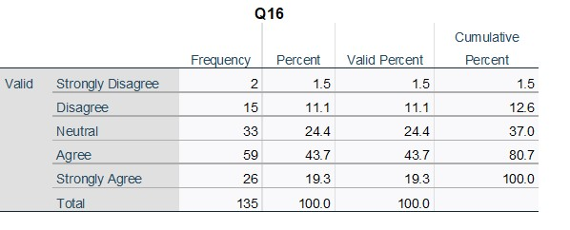
Q17- I plan a long-term career in this company
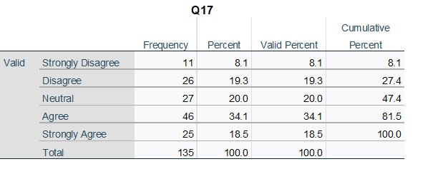
Q18-I would recommend this company as an employer
